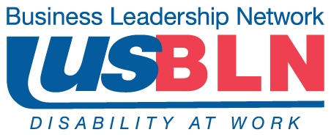

February 6, 2012

Ms. Deborah A. Carr
Director, Division of Policy, Planning and Program Development
Office of Federal Contract Compliance Programs
U.S. Department of Labor
Room C-3325
200 Constitution Avenue NW
Washington, DC 20210

Dear Ms. Carr:

On behalf of the US Business Leadership Network® (USBLN®), we are pleased to submit our written comments and offer recommendations to the U.S. Department of Labor’s Office of Federal Contract Compliance Programs (“OFCCP”) in response to your published Notice of Proposed Rulemaking of December 9, 2011.

The USBLN® is the national non-profit, non-partisan business to business network promoting workplaces, marketplaces, and supply chains where people with disabilities are included. It represents over 60 local affiliates and over 5,000 companies. The following is our rationale, followed by our recommendations, for your Office to consider in the development of its final regulation.

The USBLN® supports the U.S. Department of Labor’s intent to improve the utilization of people with disabilities in the workforce. We recognize that the current Section 503 affirmative action regulatory framework needs to be modernized, strengthened, and clarified. The USBLN® member companies are committed to including disability in all their diversity efforts and each one has developed successful policies and practices in one or more areas of the employment spectrum. It is critical to the USBLN® members continued success that the final regulations advance recruitment, hiring, retention and advancement efforts.

We would like to take this opportunity to present guiding principles that foster full inclusion of people with a wide range of disabilities and talents across the enterprise. These are based on lessons learned from our business membership.

Guiding Principles

- The federal government should be the model employer for people with disabilities as it has had inclusion mandates that preceded regulations governing the private sector. Therefore, a guiding principle should be that all requirements applicable to government contractors should, at a minimum, be made applicable to federal agencies.
- A second guiding principle is that the final regulations are harmonized across federal regulatory agencies. Therefore, we recommend that the EEOC issue a statement to confirm harmonization of requirements between the final 503 recommendations and the ADAAA.
- A third principle is that we need to support a corporate culture that welcomes and embraces people with disabilities while recognizing that what is best for one company may not be good for another company since no two companies are alike.

With the employer lens and the basic principles stated above, we will address four primary topics for which OFCCP seeks comment:

- The proposed text of the voluntary self-identification invitations that contractors would use when asking an applicant or employee to identify as an individual with a disability;

- The possible inclusion of a 2% sub-goal for individuals with certain particularly severe or targeted disabilities. OFCCP seeks comment on both the concept of using a sub-goal, and on the disabilities that should be included in such a sub-goal; and

- The use of a utilization range rather than the fixed 7% national goal the NPRM proposes. OFCCP seeks comment on a range of values between 4% and 10%.

- The requirements for outreach and recruitment, including the prescribed agencies for listing all employment opportunities.

Section 60–741.42 (Invitation to Self- identify)

RECOMMENDATION: The USBLN® recommends a user friendly invitation to self-identify that is customized by each company and contains the requirements set out in the NPRM.

The USBLN® appreciates that the proposed text for the voluntary self-identification invitation was developed to be in strict compliance with all pertinent federal laws and regulations and has been vetted by sister federal agencies and approved by the Office of Management and Budget. However, since the intent of the invitation is to facilitate affirmative action and assure the provision of reasonable accommodations for applicants and employees with disabilities, our members expressed that this long, complicated and legalese text will discourage job applicants and employees with disabilities to self-identify. This type of disclosure occurs when the employer has created a disability friendly culture and results increase if the request is made through non-traditional means such as a request issued by the chair of the disability business resource group.

Generally, the invitation to self-identify should include the following:
- A clear explanation of how the information disclosed will be used and who will have access to the information
- A statement that it is a request to afford considerations under the affirmative action program
- A statement that the request is for the employer’s affirmative action program and to meet federal legal requirements
- A statement that disclosure is voluntary and will be kept confidential
- A statement that refusal to provide it will not subject the applicant to any adverse treatment

We recommend that the proposed text be provided as guidance for each employer to create a disability friendly invitation to self identify.

The following is an example of a disability friendly invitation:

(Company XYZ) embraces diversity and inclusion in all aspects of employment. In support of our compliance efforts, we encourage and invite applicants/associates with disabilities to self identify and be included as a part of our equal employment/affirmative action program. Your self-identification is voluntary and the information provided will be maintained confidentially in accordance with legal requirements and will not subject any associate to any adverse treatment. The information collected will only be provided to those who have a strict need to know -- as part of our government audit purposes, emergency evacuation planning, and / or to increase opportunities and accessibility for applicants and our associates with disabilities.

If you would like to review the legal authority for this invitation to voluntarily self-identify, information can be found in the Office of Federal Contract Compliance Programs final regulations. (the citation and link to be inserted) If you are a person with a disability and need a reasonable accommodation to apply for a company position or to perform in your current position with our company, please apply here (this will be a link to the policies and application form) or contact (name, telephone, email) for information and a reasonable accommodation application.

Please check the box below if you have a disability.

(box) Yes, I have a disability.

Section 60–741.46 (Utilization Goal – 2% Sub-Goal)

RECOMMENDATION: The USBLN® does not recommend that a 2% sub-goal be included at this time.

Senior executives of several USBLN® member companies have publicly urged employers to establish target hiring goals for people with disabilities. They have spoken about not only setting high goals but exceeding them. And while they have hired people with a wide range of disabilities, including what the federal government terms ‘targeted disabilities,’ they have never established a separate hiring goal for people with the most significant disabilities. When one USBLN® employer asked its disability business resource group for their reaction to this 2% sub-goal, the resource group members responded that they felt that asking more than if a person has a disability infringes on their privacy.

Companies that are building a corporate culture that is inclusive of people with a wide range of disabilities have found that they have a better workplace. Hiring based on ability and qualifications is the goal. We appreciate that this will take education and higher expectations of all employees including executives, recruiters, and hiring and middle managers. We believe that hiring people with ‘targeted’ disabilities can be achieved through other means such as developing specific targeted recruitment strategies.

Section 60-741.46 Utilization Goal (Utilization Range)

RECOMMENDATION: The USBLN® supports a utilization goal and recommends a utilization range of 5 to 10%.

The NPRM raised the possibility of a utilization range of values between 4% and 10% rather than the fixed 7% national hiring goal proposed. The NPRM states that these are goals and not quotas. It also states that intent is to establish ‘an equal employment opportunity objective and an important tool for measuring the contractor’s progress toward equal employment opportunity and assessing where barriers to equal employment opportunity remain.’ The USBLN® recommends a focus on disability inclusion across the entire enterprise rather than a particular job category and we recommend the final regulation include a utilization range.

If the final rule includes a hiring goal, it needs to represent the known talent with disabilities available in the area. For example, if a high tech employer is located in a rural area with limited public transportation options and the median education level is tenth grade, it may be unrealistic to have a fixed hiring goal.

Our recommendation is that the final rule present the background research information on the number of people with disabilities in the population and suggest hiring goals between 5% and 10% for the whole workforce. This will result in more achievable goals based on the disability employment pool in the area.

If and when there is broad based consensus that the disability specific data included in the ACS is workable, we would support the same policies applicable for conducting quantitative analyses and establishing goals for women and minorities under Executive Order 11246.

Section 60-741.44(Outreach and Recruitment)

RECOMMENDATION: The USBLN® recommends that companies be allowed greater flexibility than what is prescribed in the NPRM.

The NPRM requires outreach and job listings with three prescribed entities in addition to the Employment One-Stop Career Centers. These are the state vocational rehabilitation agency, one of several prescribed organizations, and organizations listed in the employer resources section of the National Resources Directory. Many of our members have developed recruiting and hiring policies and practices that are successful in including people with disabilities within their own corporate cultures. This may include partnerships with many of the NPRM prescribed agencies or through internal company initiatives or through a combination of creative initiatives including utilizing their employee business groups to recruit job candidates with disabilities or creative marketing to the disability community via social networks. Therefore, we recommend that OFCCP not prescribe with whom a company must partner, the language the company uses in recruitment and other communications with potential or current employees, or the timeframe sufficient to judge the effectiveness of a partnership. If a contractor has no experience in disability inclusion or is failing in its efforts, then the type of prescription proposed in the NPRM may be useful as a starting point or to help them correct their course. For companies that are already successful, this prescription may result in a lack of traction or even reverse some of the progress made in employing people with disabilities.

Questions to Consider

As the regulation is finalized, there are issues that need to be clarified to enable employers to meet the intent of the regulation.

- Companies that currently ask employees to self-identify have found a large discrepancy between the number of employees that self-identify and those that formally request a reasonable accommodation based on disability. Under the final regulations, will the company be permitted to count toward their employment goal the number of individuals who request reasonable accommodations?
- Companies have found that many individuals with obvious disabilities such as wheelchair users do not respond to self-identification requests. Moreover, if the physical environment is accessible, including furniture and information and electronic technologies, a reasonable accommodation may never be requested. Under the final regulations, will the company be permitted to include employees with obvious disabilities in the count to meet their employment goal?
- Some companies have “referral source” information in their applicant tracking systems. If these sources are entities that have disability eligibility requirements, can these be counted in absence of a self-identification at application?
- USBLN® businesses that have experienced success in recruiting and employing people with disabilities report that it can be a process that takes time to build community partnerships and change the corporate culture. Under the final regulations will there be a phase-in period for companies to reach the proposed 7% goal?

The USBLN® thanks you for this opportunity to provide our input into the formulation of the government’s final 503 regulations. We offer our assistance in its implementation.

Sincerely,

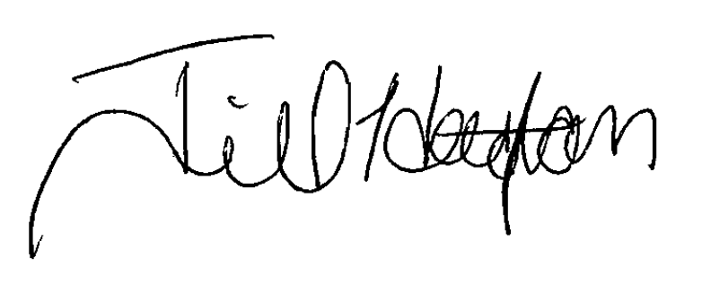

Deb Russell Jill D. Houghton
USBLN® Board Chair USBLN® Executive Director

Deb russell, BOARD CHAIR, USBLN® Jill houghton, Executive Director
Manager, diversity & inclusion, walgreens US BUSINESS LEADERSHIP NETWORK -USBLN®
102 Wilmot Road, Deerfield, IL 60015 1310 Braddock Pl, STE 101, Alexandria, VA 22314
847-315-8882 954-461-4726
Deb.Russell@walgreens.com Jilldh@bellsouth.net

