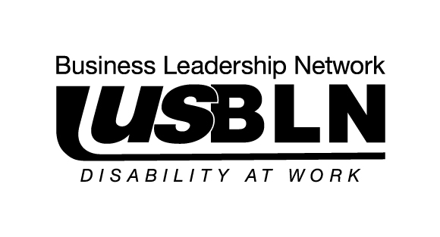

USBLN® Announces its 2012 Board of Directors and Officers

For Immediate Release Contact: Anita Howard
February 16, 2012 Phone: (800) 706-2710 anita@usbln.org

WASHINGTON, DC (February 16, 2012) - Today, the US Business Leadership Network® (USBLN®) announced its 2012 Board of Directors and Board Officers. Re-elected member representation on the USBLN® Board of Directors this year includes Ann Andreosatos, Leader, Culture and Capability, North American Diversity & Inclusion Practice, Procter & Gamble; Kevin Foster, Director of Motorola’s Quality Master Black Belt; and Keith Wiedenkeller, Senior Vice President and Chief People Officer, AMC Entertainment Inc. (AMC).

The full USBLN® Board of Directors went on to elect Deb Russell, Corporate Manager, Diversity and Inclusion, Walgreens as Chair and Debra Ruh, Chief Marketing Officer, SSB BART Group Inc. as Secretary/Treasurer returning to the Board in their incumbent seats with Deborah Dagit, Vice President and Chief Diversity Officer, Merck newly elected to serve as Vice-Chair.

“We are pleased to announce our 2012 Board of Directors and Officers and greatly value their collective insight. Each of our Directors brings a strong background and overall business acumen that significantly supports the USBLN®’s strategic growth. I’m confident that this Board will help us build upon its many accomplishments and further enhance disability inclusion across the enterprise,” shared Deb Russell, USBLN® Board Chair and Corporate Manager, Diversity and Inclusion, Walgreens.

The USBLN® Board of Directors is also comprised of existing members: Martha Artiles, Partner, C5 Consulting LLC; Beth Butler, Director, Diversity & Inclusion Lowe's Companies, Inc.; Frances West, Director, IBM’s Human Ability & Accessibility Center; Marthalee Galeota, Program Manager of Starbuck’s Accessibility; Michelle Maybaum, Director, Employee Relations for Qualcomm, Inc.; Lori Golden, Inclusiveness Consultant and Lead of Ernst & Young’s firm-sponsored inclusiveness initiative AccessAbilities; and Susan Palmer Mazrui, Director, Global Public Policy, AT&T Services Inc.

The three Ex Officio Board members are Paul Fogle, student, Penn State Harrisburg and Chair, USBLN® Student Advisory Council, Tessah Latson Garcia, Program Director, New Mexico Business Leadership Network and USBLN® BLN Affiliates Representative; and John Wagner, MHA, Senior Segment Director for the Senior Business Unit, Blue Cross and Blue Shield of Florida and Chair, USBLN® Corporate Advisory Board. These members provide important representation of their respective advisory groups, the USBLN® Student Advisory Council, the BLN Affiliates, and the Corporate Advisory Board.

For more information on the USBLN® Board of Directors, please visit http://usbln.org/bod.html.

About the US Business Leadership Network® (USBLN®)
The US Business Leadership Network® (USBLN®) is a national non-profit, non-partisan business to business network promoting workplaces, marketplaces, and supply chains where people with disabilities are included. The USBLN® serves as the collective voice of over 60 Business Leadership Network affiliates across the United States, representing over 5,000 businesses. Additionally, the USBLN® Disability Supplier Diversity Program® (DSDP) is the nation’s leading third party certification program for disability-owned businesses, including service-disabled veterans. www.usbln.org

####

