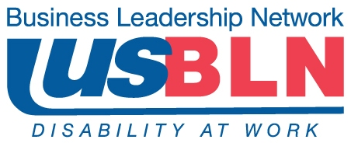

USBLN® Position Statement about
Subminimum Wage for Workers with Disabilities

The US Business Leadership Network® (USBLN®) is a national, non-profit, non-partisan business-to-business network promoting workplaces, marketplaces, and supply chains in which people with disabilities are included. The USBLN® serves as the collective voice of over 60 Business Leadership Network affiliates across the United States, representing over 5,000 businesses. Additionally, the USBLN® Disability Supplier Diversity Program® (DSDP) is the nation's leading third-party certification program for disability-owned businesses, including service-disabled veterans.

The USBLN® promotes workplaces, marketplaces, and supply chains in which people with disabilities can realize their full potential and be respected for their talents, economic self-sufficiency, and entrepreneurship. USBLN® members recognize the return on investment in recruiting and retaining the best talent regardless of disability.

Under current laws, employers may not discriminate against qualified individuals with disabilities who with or without reasonable accommodations can perform the essential functions of the job. Section 14(c) of the Fair Labor Standards Act (FLSA) allows the Secretary of Labor to grant special wage certificates to employers, permitting them to pay their workers with disabilities less than the minimum wage. Section 14(c) was intended to be used only "to the extent necessary to prevent curtailment of opportunities" for employment of people with disabilities. The USBLN® believes that this exception in for-profit companies is unnecessary and counter to the goals of equal opportunity.

Many USBLN® member companies have taken proactive measures to hire qualified individuals with significant disabilities who had unnecessarily worked in segregated environments in which they earned significantly below minimum wage. Once entering a competitive work environment with reasonable accommodations and training, these qualified employees are able to maintain and exceed performance standards, often earning well above minimum wage, in an integrated setting. We maintain that all qualified employees, including those with disabilities, should receive equal pay for equal work as do their colleagues without disabilities. As an organization, the USBLN® is committed to this end.

