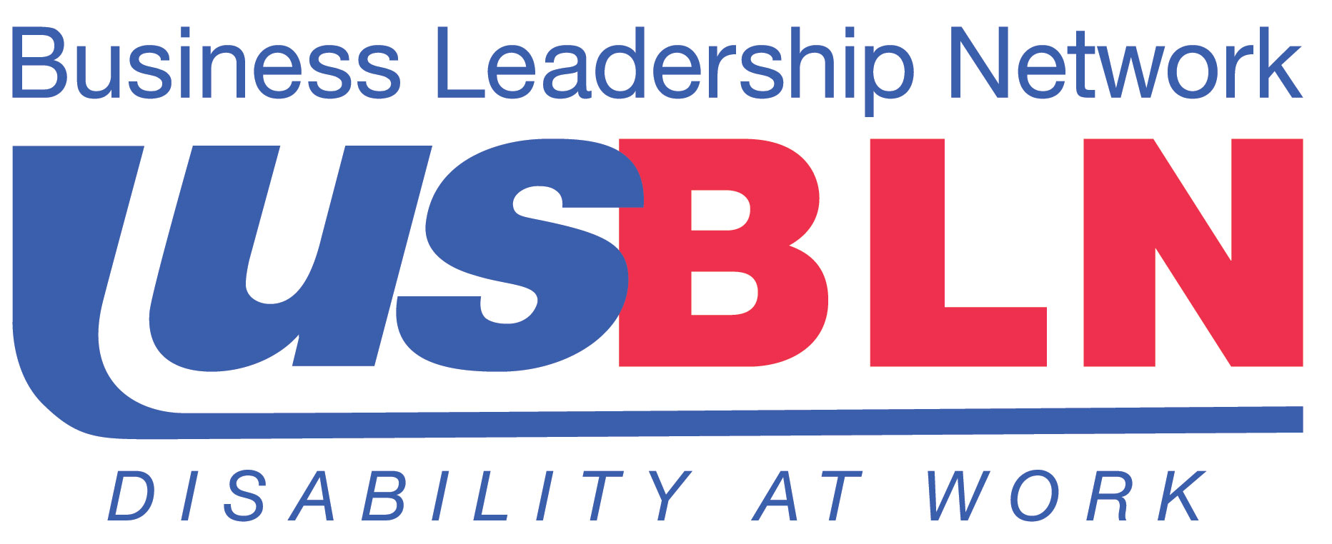

USBLN® Applauds its 2013 Annual Conference Track Chairs

For Immediate Release Contact: Anita Howard
August 27, 2013 Phone: (800) 706-2710 anita@usbln.org

WASHINGTON, DC (August 27, 2013) – Today, the US Business Leadership Network® (USBLN®) recognized its 2013 Annual Conference Educational Track Co-Chairs for their leadership in developing the Workplace, Supply Chain and Marketplace programming at their upcoming 16th Annual Conference & Expo entitled, "Lights, Camera, Access: Spotlight on Disability Inclusive Diversity" in Los Angeles, California on September 30-October 3.

Track Chair representation for the USBLN® 16th Annual Conference & Expo includes Workplace track Co-Chairs; Michael Johnson, Director, Diversity & Inclusion, McKesson Corporation; and Robert (Bob) J. Vetere, Senior Workplace Accommodation Specialist, Global Corporate Responsibility, Northrop Grumman Corporation; Supply Chain track Co-Chairs; Anthony (Tony) Billinger, Director, Supplier Diversity, OfficeMax; and Darlene Fuller, Senior Director, Supplier Diversity, Sodexo and Marketplace track Co-Chairs; Jenny Lay-Flurrie, Senior Director, Accessibility, Customer Partner Advocacy (CPA), Microsoft; and Rhea C. Norwood, MHCS, MarketPlace Director of Diversity Inclusion, Lowe’s Companies Inc.

“We’re so fortunate to have such strong Track Chairs. The USBLN® is focused on being the trusted advisor for business on disability inclusion and deeply values the important contributions of each of the conference Track Chairs,” shared Jill Houghton, Executive Director, USBLN®.

Michael Johnson is employed by Fortune 14 Company McKesson Corporation as Director of Diversity and Inclusion. In his Diversity & Inclusion role, Michael works closely with Human Resources, McKesson business units, and Corporate Communications to bring diversity and inclusion thought leadership to business strategy. His strategic objectives are to develop and implement Diversity Talent Sourcing and retention strategy, Employee Resource Groups strategy and Marketplace partnerships, business and diversity opportunities, and search externally for leading trends, innovation and thought. Michael is also the former inaugural Chair of the McKesson African American Employee Resource Group, ASPIRE.

Robert (Bob) J. Vetere recently celebrated his 35th anniversary with Northrop Grumman. In his current position, Mr. Vetere will assist in providing a harmonized approach to the reasonable accommodation process across the Enterprise. Prior to accepting this position, he served as EEO/Diversity specialist for Northrop Grumman’s Electronic Systems Sector. During his career with Northrop Grumman, Mr. Vetere created the Victory Over Impairment & Challenge Enterprise Employee Resource Group (VOICE) at Northrop and has a passion for serving both his community and corporation.

Anthony (Tony) Billinger is the Director of Supplier Diversity at OfficeMax and is responsible for creating and implementing the enterprise-wide strategy for supplier diversity. Anthony joined OfficeMax in June 2009 after previously serving as the architect of the supplier diversity initiative at Snap-on Tools, headquartered in Kenosha, Wisconsin and has lead supplier diversity initiatives for the past 17 years. He currently serves on the executive board of the Chicago Minority Supplier Development Council.

Darlene Fuller works within Sodexo’s Supply Management Department leading their supplier diversity efforts. Ms. Fuller is a long term employee of the company, beginning her career in operations for their Health Care division of Saga She has held positions in Distribution and both national and regional purchasing for Marriott then Sodexo.

Jenny Lay-Flurrie is Senior Director of Accessibility Customer Experience within Customer Partner Advocacy, Microsoft, working for Rich Kaplan, Vice President. Previously, Jenny spent five years leading the Advertising Support and Services (AdSS) organization responsible for the service and support of Microsoft Search Online Advertising Products (Bing/AdCenter). She has also led the EMEA consumer support team for Customer Service and Support (CSS), based in London.

Rhea C. Norwood has a passion for developing people and organizations. For more than 15 years, companies have relied on Rhea to provide innovative solutions for meeting their human capital needs. A specialist in talent acquisition, learning and development, employee relations and diversity and inclusion, she has performed an integral role in helping companies save millions of dollars while building high-performance teams. Currently MarketPlace Director of Diversity Inclusion for Lowe’s Companies, Rhea continues her focus on collaborating with suppliers, customers, employees and the community-at-large to drive innovative solutions for the enterprise.

For more information and to register for the USBLN® 16th Annual Conference & Expo, please visit http://www.usblnannualconference.org/.

About the US Business Leadership Network® (USBLN®)
The US Business Leadership Network® (USBLN®) is a national non-profit that helps business drive performance by leveraging disability inclusion in the workplace, supply chain, and marketplace. The USBLN® serves as the collective voice of over 50 Business Leadership Network affiliates across the United States, representing over 5,000 businesses. Additionally, the USBLN® Disability Supplier Diversity Program® (DSDP) is the nation’s leading third party certification program for disability-owned businesses, including businesses owned by service-disabled veterans. www.usbln.org

# # #

