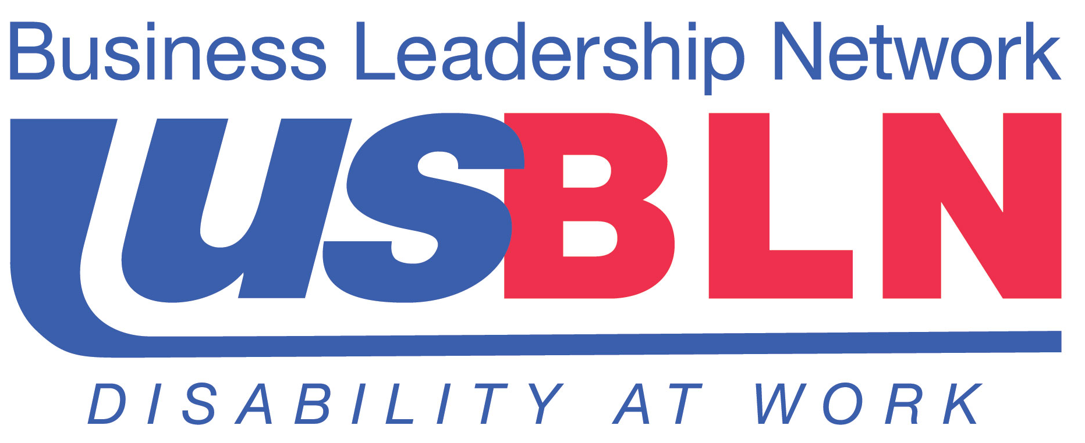

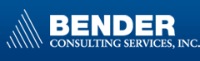

Invitation to Businesses to Participate in the “Bender Virtual Career Fair”
on October 10, 2013

For Immediate Release Contact: Anita Howard
August 29, 2013 Phone: (800) 706-2710
anita@usbln.org
WASHINGTON, DC (August 29, 2013) – The US Business Leadership Network® (USBLN®) is pleased to invite employers to participate in the Bender Virtual Career Fair on October 10, 2013, hosted by Bender Consulting Services. This Virtual Career Fair offers an opportunity to add talent to your workforce while increasing your disability diversity recruitment objectives from the convenience of your office. The most recent Bender Virtual Career Fair for People with Disabilities included over 1000 college students and graduates.
Join other forward-thinking Fortune 500 companies and entrepreneurial organizations that are leveraging the power of technology to reach the top talent without the travel. This is a unique opportunity to connect with this untapped labor pool!

REGISTER HERE: http://www.disability.careereco.net

Virtual Career Fair Participation Levels Include:
- Regular Employer Registration: $495 (before September 23, 2013)
- Website Sponsor: $1000
- Event Sponsor: $2000

WHY PARTICIPATE?

EXPAND OUTREACH TO SATISFY DIVERSITY OBJECTIVES.
Access the untapped talent pool of people with disabilities
- National candidate participation
- Including Veterans with disabilities

COLLEGE STUDENTS & RECENT COLLEGE GRADS
Connect with a dedicated and loyal labor force
- For full-time opportunities and internships
- Reach Business, STEM, and Liberal Arts majors

IMPACT THE BOTTOM LINE
Eliminate travel and reduce recruiting and outreach costs
- The most recent Virtual Fair included over 1,000 job seekers with disabilities
- Recruitment nationwide from the convenience of your office

HAVE QUESTIONS?

For more information contact: bender@careereco.com or 770.980.0088.

Bender Consulting Services is a USBLN® certified disability-owned business enterprise. For more information on the USBLN’s certification process and Disability Supplier Diversity Program® (DSDP®), please visit: http://www.usbln.org/dsdp_overview.html.

About the US Business Leadership Network® (USBLN®)
The US Business Leadership Network® (USBLN®) is a national non-profit that helps business drive performance by leveraging disability inclusion in the workplace, supply chain, and marketplace. The USBLN® serves as the collective voice of over 50 Business Leadership Network affiliates across the United States, representing over 5,000 businesses. Additionally, the USBLN® Disability Supplier Diversity Program® (DSDP) is the nation’s leading third party certification program for disability-owned businesses, including businesses owned by service-disabled veterans. www.usbln.org

# # #

