US Business Leadership Network® (USBLN®)
1310 Braddock Place, Suite 101
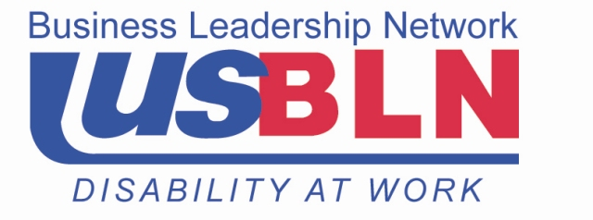
Alexandria, VA 22314
Phone: (800) 706-2710
Fax: (800) 706-1335
info@usbln.org
www.usbln.org

December 6, 2013

The Honorable Robert Menendez The Honorable Bob Corker
528 Senate Hart Office Building 425 Dirksen Senate Office Building
Washington, D.C. 20510 Washington, D.C. 20510

Dear Senators:

On behalf of the undersigned businesses, we want to express our support for the U.S. ratification of the Convention on the Rights of Persons with Disabilities (CRPD), subject to the Reservations, Understandings and Declaration (RUDs) submitted by the Administration. U.S. participation with the CRPD would help to promote U.S. business leadership in international markets, advance equal access and opportunity, and encourage greater global community inclusion for people with disabilities.

Ratification of the CRPD, subject to the RUDs, would require no change in U.S. laws. However, US leadership in ratifying this treaty would potentially encourage other countries with less comprehensive systems of disability laws to ratify the treaty, which in turn would help create important changes for U.S. business. If adopted in other countries, the CRPD would help to: increase opportunities in international markets and exports for U.S. companies, promote U.S. disability standards internationally, and support U.S. public and private research and U.S. academic leadership in global accessibility innovations.

U.S. ratification of the CRPD can help support these advancements throughout the world. We thank you for your support for U.S. business and your consideration of this important treaty.

Sincerely,

Mary Dale Walters, Senior Vice President, Consumer Sales and Marketing, Allsup

Keith P. Wiedenkeller, Senior Vice President and Chief People Officer, AMC Entertainment Inc.

Tim McKone, Executive Vice President-Federal Relations, AT&T

Nancy J. Di Dia, Executive Director, Chief Diversity Officer, Boehringer Ingelheim USA

Aida Sabo, Vice President of Diversity & Inclusion, Cardinal Health

Steve Bucherati, Chief Diversity Officer, The Coca-Cola Company

Preety Kumar, CEO, Deque Systems, Inc.

Stephen Feinberg, Chairman of the Board, Dorsar Investment Co.

Michael Small, President & CEO, Gogo

Ray Carson, Executive Vice President & Chief Human Resources Officer & Maureen Cahill, Vice President Total Rewards and Executive Sponsor, Abilities Business Resource Group, Highmark

Frances W. West, Worldwide Director, IBM Human Ability & Accessibility Center, IBM

Patricia David, Head of Diversity, JPMorgan Chase & Co.

Jorge Perez, Senior Vice President, ManpowerGroup North America

Dottie Brienza, Chief Diversity Officer and Executive Talent Development Leader, Merck & Co., Inc.

Lisa Brummel, Executive Vice President of Human Resources, Microsoft Corporation

Sandra Evers-Manly, Vice President, Global Corporate Responsibility, Northrop Grumman Corporation

Carolynn Brooks, Vice President, Chief Diversity Officer, President, OfficeMax Charitable Foundation

Chris Moranda, LSW, CDMS, Manager, Disability Services, Associate Health and Wellness, OhioHealth

Madonna Long, Consumer Advocate, Pride Mobility Products

Rohini Anand, Senior Vice President and Global Chief Diversity Officer, Sodexo

Bill Barloon, Vice President State and Federal Legislative Affairs, Sprint

Cecily Joseph, Chief Diversity Officer and Vice President Corporate Responsibility, Symantec Corporation

Gail MacKinnon, Executive Vice President and Chief Government Relations Officer, Time Warner Cable

Magda Yrizarry, Vice President and Chief Talent and Diversity Officer, Verizon

Frank McCloskey, Retired Vice President Diversity Georgia Power

Marge Plasmier, Director of Business and Government Accounts, ABILITY Jobs

Roy Lanza, CEO, A3 Accounting Associates

Joyce Bender, CEO/President, Bender Consulting Services, Inc.

Patricia Graves, President, Caption First, Inc.

Joanna Barsh, President, The Centered Leadership Project, LLC

Mike Chamblee, Owner, Chamblee Fences

Howard Ross, Founder and Chief Learning Officer, Cook Ross Inc.

Elizabeth Birch, President, Elizabeth Birch Company/Global Out

Margaret A. Regan, President & CEO, The Future Work Institute, Inc.

Jane Hyun, Founder & President, Hyun & Associates Leadership Consultants

Willie Davis, President, Matrix Systems and Technologies

Linda Plummer, Owner, Plummer & Associates

Donna Lisa Hunte-Dobbs, CEO, Projects and Intellectual Properties (d/b/a)

Toni L Riccardi, CEO, RED Consulting

Debra Ruh, Owner, Ruh Global LLC

Debbie Phillips, President, WFD Consulting Inc.

Dale Ross, Owner, Wild Watercolors

Bob Witeck, President, Witeck Communications, Inc.

Sincerely,

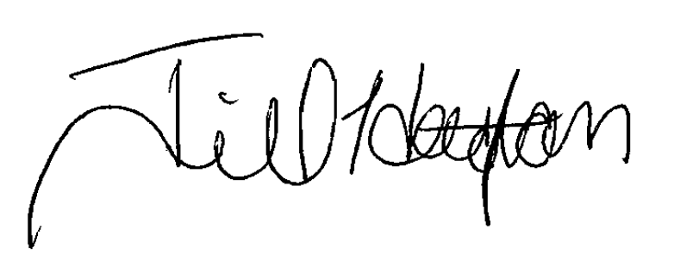
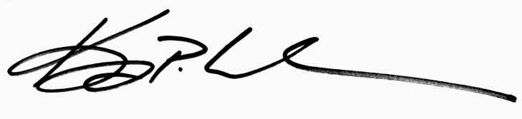

Keith P. Wiedenkeller Jill B. Houghton
USBLN® Board Chair USBLN® Executive Director

