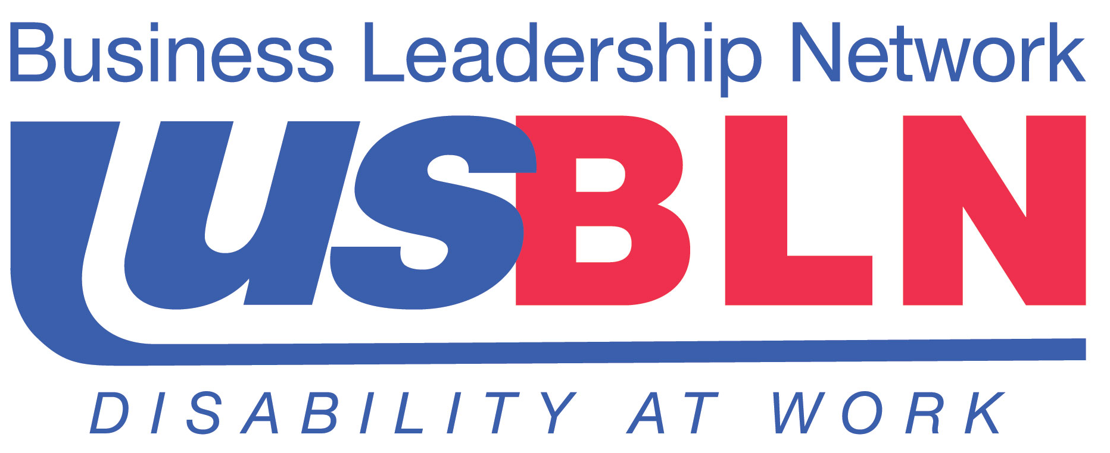

Disability Equality IndexSM “Soft” Launch Announced

For Immediate Release Contact: Anita Howard
October 1, 2013 Phone: (800) 706-2710 anita@usbln.org

WASHINGTON, DC (October 1, 2013) – The US Business Leadership Network® (USBLN®) and the American Association of People with Disabilities (AAPD) have issued a call for Fortune 1000 companies to participate in the pilot phase of the Disability Equality IndexSM (DEISM). The DEISM is a national, transparent benchmarking tool that will offer major employers the opportunity to receive an objective score on their disability inclusion policies and practices and identify avenues for continued improvement. It is also intended to help build a company’s reputation as an employer of choice.

The “soft” launch or pilot phase was announced today at the USBLN® 16th Annual Conference & Expo in Los Angeles, California. The purpose of the pilot phase is to refine the DEISM survey further prior to the 2014 launch of the first Annual DEISM survey.

“The feedback about the DEISM at the USBLN® Annual Conference has been overwhelmingly positive,” said Jill Houghton, Executive Director, USBLN®. “The opportunity to participate in the pilot is a very unique opportunity and we are excited to report that employers are already stepping forward.”

“With new requirements that federal contractors set hiring targets for people with disabilities, contractors and other employers are looking for new ways to appeal to the untapped workforce and growing purchasing power of Americans with disabilities,” said Mark Perriello, President and CEO, AAPD. “Created by leaders in the business and disability community, the DEISM is poised to be a powerful educational tool for all those seeking information on a company’s disability related efforts.”

The deadline to apply to be considered for participation in the pilot phase is November 15, 2013. There is no fee to participate. Additionally, pilot participants will receive:

- Exclusive access to view the DEISM survey questions and receive unofficial, non-public results
- The unique opportunity to work with and provide feedback on the survey to DEISM staff

Fortune 1000 companies interested in participating or needing more information about the pilot should contact Jani Willis at jani@usbln.org.

For more information on the DEISM and the pilot launch please visit: http://www.usbln.org/programs-dei.html

About the US Business Leadership Network® (USBLN®)
The US Business Leadership Network® (USBLN®) is a national non-profit that helps business drive performance by leveraging disability inclusion in the workplace, supply chain, and marketplace. The USBLN® serves as the collective voice of over 50 Business Leadership Network affiliates across the United States, representing over 5,000 businesses. Additionally, the USBLN® Disability Supplier Diversity Program® (DSDP) is the nation’s leading third party certification program for disability-owned businesses, including businesses owned by service-disabled veterans. www.usbln.org

About the AAPD
The American Association of People with Disabilities is the nation's largest disability rights organization. AAPD promotes equal opportunity, economic power, independent living, and political participation for people with disabilities. AAPD’s members, including people with disabilities and family, friends, and supporters, represent a powerful force for change. To learn more, visit the AAPD Web site: www.aapd.com.

# # #

