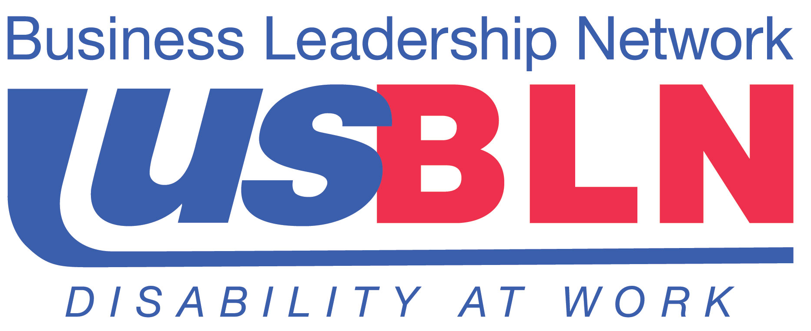

National Governors Association Releases
“A Better Bottom Line: Employing People with Disabilities”

For Immediate Release Contact: Anita Howard
August 5, 2013 Phone: (800) 706-2710 anita@usbln.org

WASHINGTON, DC (August 5, 2013) – The National Governors Association unveiled a new publication entitled, A Better Bottom Line: Employing People with Disabilities at its national conference in Milwaukee, Wisconsin last week. The report frames Governor Markell’s initiative to increase employment among individuals with intellectual and other significant disabilities and the role that both state government and business can play in facilitating and advancing opportunities for these individuals to be gainfully employed in the competitive labor market.
Governor Jack Markell, Delaware, National Governors Association Chair, 2012-2013, stated, “Successfully achieving this goal will require not only attention to appropriate training, job placement, and work-based support but also advancing best practices and meaningful engagement of the business community. Because government, business, the general public, individuals with disabilities and their families all stand to benefit from increased employment of people with disabilities, all have a role and shared responsibility in reaching this goal.”
Jill Houghton, Executive Director, USBLN®, stated “The USBLN® thanks Governor Markell for his leadership and vision through his National Governors Association (NGA) Chair’s Initiative to advance the employment of people with significant disabilities. Clearly, all governors across regions and parties are interested in advancing employment and the USBLN® looks forward to bringing BLN affiliates, corporate members and certified disability-owned businesses together to assist in making the initiative a reality in every state, territory and commonwealth.”

The initiative will provide governors and other state policymakers with better policy options to assess the environment in their state and strategies designed to support this population. A major emphasis will be on people who have significant intellectual and developmental disabilities and may require supports like job coaches and personal attendants in order to live and work in the community. The National Governors Association will convene governors, businesses, disability leaders and other thought leaders throughout the year to share ideas and move forward with support for this population.

The “A Better Bottom Line: Employing People with Disabilities” report is available here.

About the US Business Leadership Network® (USBLN®)
The US Business Leadership Network® (USBLN®) is a national non-profit that helps business drive performance by leveraging disability inclusion in the workplace, supply chain, and marketplace. The USBLN® serves as the collective voice of over 50 Business Leadership Network affiliates across the United States, representing over 5,000 businesses. Additionally, the USBLN® Disability Supplier Diversity Program® (DSDP) is the nation’s leading third party certification program for disability-owned businesses, including businesses owned by service-disabled veterans. www.usbln.org

# # #

