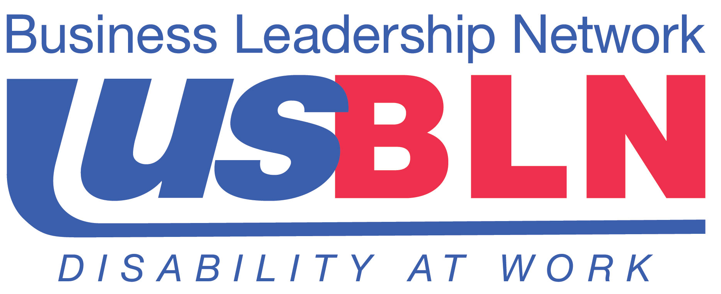

USBLN® Announces an Exclusive Webinar on Workplace Accommodations for Employees with Mental Health Disabilities

For Immediate Release Contact: Anita Howard
June 4, 2013 Phone: (800) 706-2710 anita@usbln.org

WASHINGTON, DC (June 4, 2013) – The US Business Leadership Network® (USBLN®) in partnership with the Boston University Center for Psychiatric Rehabilitation and the Job Accommodation Network (JAN) is pleased to offer its members and allies a cost-free webinar on this critical topic on Thursday, June 20, 2013 from 2:00-3:00 p.m. EST.
This webinar will present a summary of quantitative and qualitative research studies as well as lessons learned from several decades of technical assistance by two national centers (Boston University and the Job Accommodation Network.) Presenters will discuss promising practices revealed in the studies and emerging workplace trends.
You will also hear about a recent initiative at Boston University on Creating an Inclusive Workplace. This program addresses positive approaches to reducing or eliminating discrimination and stigma at work.
Presenters:
- Joan Rapp, Coordinator Continuing Education, Boston University, Center for Psychiatric Rehabilitation
- Melanie Whetzel, Senior Consultant, Cognitive /Neurological Team, Job Accommodation Network
Attendees are asked to register by June 18, 2013.
To register online: http://cpr.bu.edu/develop/webinar/usbln.
To register by email: joanrapp@bu.edu or fax: 617-353-7700 please send the following information by June 18, 2013:
- Name
- Role or Title
- Organization
- Address
- Email
- Phone
To access the webinar on June 20, 2013: Log on http://bu.adobeconnect.com/usbln/
Webinar participants are asked to register as a guest and will be given a toll free number to call into the webinar.
About the US Business Leadership Network® (USBLN®)
The US Business Leadership Network® (USBLN®) is a national non-profit that helps business drive performance by leveraging disability inclusion in the workplace, supply chain, and marketplace. The USBLN® serves as the collective voice of over 50 Business Leadership Network affiliates across the United States, representing over 5,000 businesses. Additionally, the USBLN® Disability Supplier Diversity Program® (DSDP) is the nation’s leading third party certification program for disability-owned businesses, including businesses owned by service-disabled veterans. www.usbln.org

# # #

