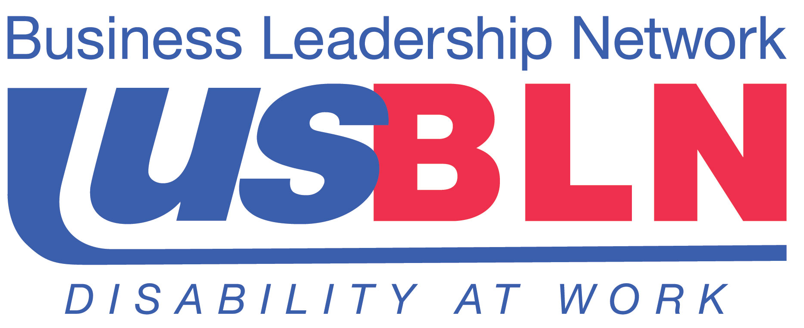

USBLN Strategic Partnerships Advancing Disability Inclusion in Business
on the 24th Anniversary of the Americans with Disabilities Act (ADA)

For Immediate Release Contact: Anita Howard
July 25, 2014 Phone: (800) 706-2710 anita@usbln.org

WASHINGTON, DC (July 25, 2014) – As we celebrate the 24th anniversary of the Americans with Disabilities Act (ADA), the US Business Leadership Network® (USBLN®) is excited about the many recent productive partnerships that have been forged resulting in cutting edge events and initiatives to fulfill the promise of the ADA of full inclusion of people with disabilities in every aspect of life, including employment.

On June 26, 2014, in partnership with the American Association of People with Disabilities (AAPD), the USBLN unveiled the first Annual Disability Equality IndexSM (DEISM). Created by the DEI Advisory Committee, a diverse group of business leaders, policy experts, and disability advocates, the DEI is an online benchmarking tool that offers businesses the opportunity to receive an objective score, on a scale of zero to 100, on their disability inclusion policies and practices. It is an aspirational, educational, recognition tool that is intended to help companies identify opportunities for continued improvement on their disability inclusion initiatives, as well as, help build a company's reputation as an employer of choice. The first Annual DEI survey will launch in October 2014 during the 2014 USBLN Annual National Conference & Biz2Biz Expo. To view the DEI survey or for more general information, please visit: http://usbln.org/programs-dei.html

The USBLN partnered with the State of Rhode Island, Rhode Island College, and Walgreens to host the June 27, 2014, “New England Workplace Inclusion and Equality Summit: People with Disabilities Reaching Competitive Employment” to help streamline the recruitment and hiring of employees with disabilities. The event was held in Providence, Rhode Island. This highly successful event demonstrated a unified commitment to share best practices, identify barriers to hiring individuals with disabilities, and propose meaningful recommendations for overcoming such barriers, resulting in real commitments to employing individuals with disabilities.

USBLN Executive Director Jill Houghton and National Council on Independent Living (NCIL) Executive Director Kelly Buckland signed a strategic alliance agreement to formalize their mutual collaboration to drive disability inclusion awareness and to advance, improve and expand employment outcomes for individuals with disabilities. NCIL represents thousands of organizations and individuals from every state including: individuals with disabilities, Centers for Independent Living (CILs), Statewide Independent Living Councils (SILCs), and other organizations that advocate for the human and civil rights of people with disabilities throughout the United States. To learn more, visit: www.ncil.org.

Finally, the USBLN is a founding member of the Campaign for Disability Employment (CDE), a collaboration between the U.S. Department of Labor’s Office of Disability Employment Policy and leading disability and business organizations. The CDE provides a range of resources, including posters and fact sheets as well as public service announcements, to promote the hiring, retention, and advancement of people with disabilities. For more information and to order materials, visit www.WhatCanYouDoCampaign.org.

Register now for the US Business Leadership Network's 17th Annual Conference being held this year from September 29 through October 2 in Orlando, Florida at the Renaissance Orlando at SeaWorld by Marriott. The 2014 USBLN Annual National Conference & Biz2Biz Expo is the preeminent national business to business event that focuses on disability inclusion in the workplace, supply chain and marketplace.

About the US Business Leadership Network (USBLN)
The US Business Leadership Network (USBLN) is a national non-profit that helps business drive performance by leveraging disability inclusion in the workplace, supply chain, and marketplace. The USBLN serves as the collective voice of nearly 50 Business Leadership Network affiliates across the United States, representing over 5,000 businesses. Additionally, the USBLN Disability Supplier Diversity Program® (DSDP) is the nation’s leading third party certification program for disability-owned businesses, including businesses owned by service-disabled veterans. www.usbln.org

# # #

