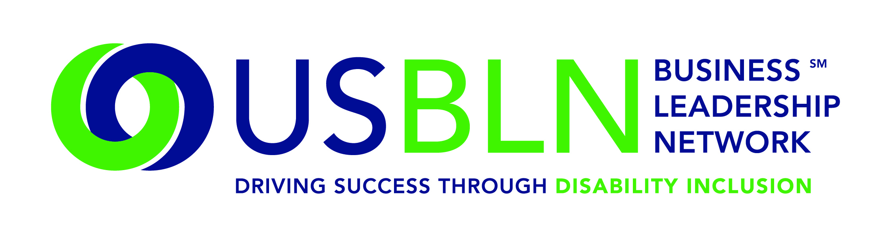

Record Breaking Attendance at the 2014 USBLN 17th Annual National Conference
& Biz2Biz Expo

For Immediate Release Contact: Anita Howard
October 1, 2014 Phone: (800) 706-2710 anita@usbln.org

WASHINGTON, DC (October 1, 2014) – The US Business Leadership Network® (USBLN®) 17th Annual National Conference & Biz2Biz Expo held in Orlando, Florida has sold out with record breaking attendance of over 600 corporate, government, disability-owned businesses and BLN affiliates with nearly half as first time conference attendees.
The 2014 USBLN 17th Annual National Conference & Biz2Biz Expo, “A Sea of Opportunity: Disability Inclusion for Innovation & Growth” is the preeminent national business to business event that focuses on disability inclusion in the workplace, supply chain, and marketplace. An amazing line-up of conference partners, stakeholders, exhibitors and supporters contributed to the success of the conference.

Highlights of the commencement of the 2014 USBLN 17th Annual National Conference & Biz2Biz Expo included:

- The Opening Plenary session featured a dynamic dialogue with keynotes Belinda Reed Shannon, Vice President, Equality & Inclusion, GlaxoSmithKline, Workplace Track Chair; Keith Wiedenkeller, Chief People Officer, AMC Theatres, (AMC) (Retired), President & CEO, Humane Society of Greater Kansas City, Chair, USBLN; Anka Wittenberg, Senior Vice President, Chief Diversity & Inclusion Officer, SAP AG; David L. Casey, Vice-President, Workforce Strategies & Chief Diversity Officer, CVS Health and David L. Gonzales, Global Chief Diversity Officer, Merck & Co.
- Companies learned how they can benefit from the Disability Equality IndexSM (DEISM) during its historic launch, a joint initiative of the USBLN and AAPD, which is a national, transparent benchmarking tool that offers businesses an opportunity to receive an objective score, on a scale of zero to 100, on their disability inclusion policies and practices;
- Highly-successful industry leaders including Apoorva N. Gandhi, Vice President, Multicultural Affairs, Marriott International, Inc.; Marketplace Track Chair, David O'Brien, Americas Director of Brand, Marketing and Communications, Ernst & Young; Jenny Lay-Flurrie, Senior Director, Trusted Experience Team (TExT), Microsoft; The Honorable Kathleen Martinez, Assistant Secretary of Labor for Disability Employment Policy; and Colleen Fukui-Sketchley, Corporate Center Diversity Affairs Director, Nordstrom, Inc. shared the business case for developing and marketing products and services to the disability community through innovation, advertising and brand strategies;
- A Veterans Community Service Project where attendees prepared non-perishable food care packages to be distributed to returning and homeless veterans and their families at the Orlando VA Healthcare System; and
- The sold out “Power of Partnerships” Expo where exhibitors dedicated to disability inclusion showcased their products, services, and technology to assist in the development of strategies for success across workplaces, supply chains and marketplaces.

Save the Date for the 2015 USBLN 18th Annual National Conference & Biz2Biz Expo
Mark your calendar now for the 18th Annual USBLN Conference to be held in Austin, Texas on September 28-October 1, 2015 at the Renaissance Austin hotel. This event will kick-off National Disability Employment Awareness Month (NDEAM) and celebrate the 25th Anniversary of the signing of the Americans with Disabilities Act. Event details will be made available at: www.usblnannualconference.org.

About the US Business Leadership Network (USBLN)
The US Business Leadership Network (USBLN) is a national non-profit that helps business drive performance by leveraging disability inclusion in the workplace, supply chain, and marketplace. The USBLN serves as the collective voice of nearly 50 Business Leadership Network affiliates across the United States, representing over 5,000 businesses. Additionally, the USBLN Disability Supplier Diversity Program® (DSDP) is the nation’s leading third party certification program for disability-owned businesses, including businesses owned by service-disabled veterans. www.usbln.org

####

