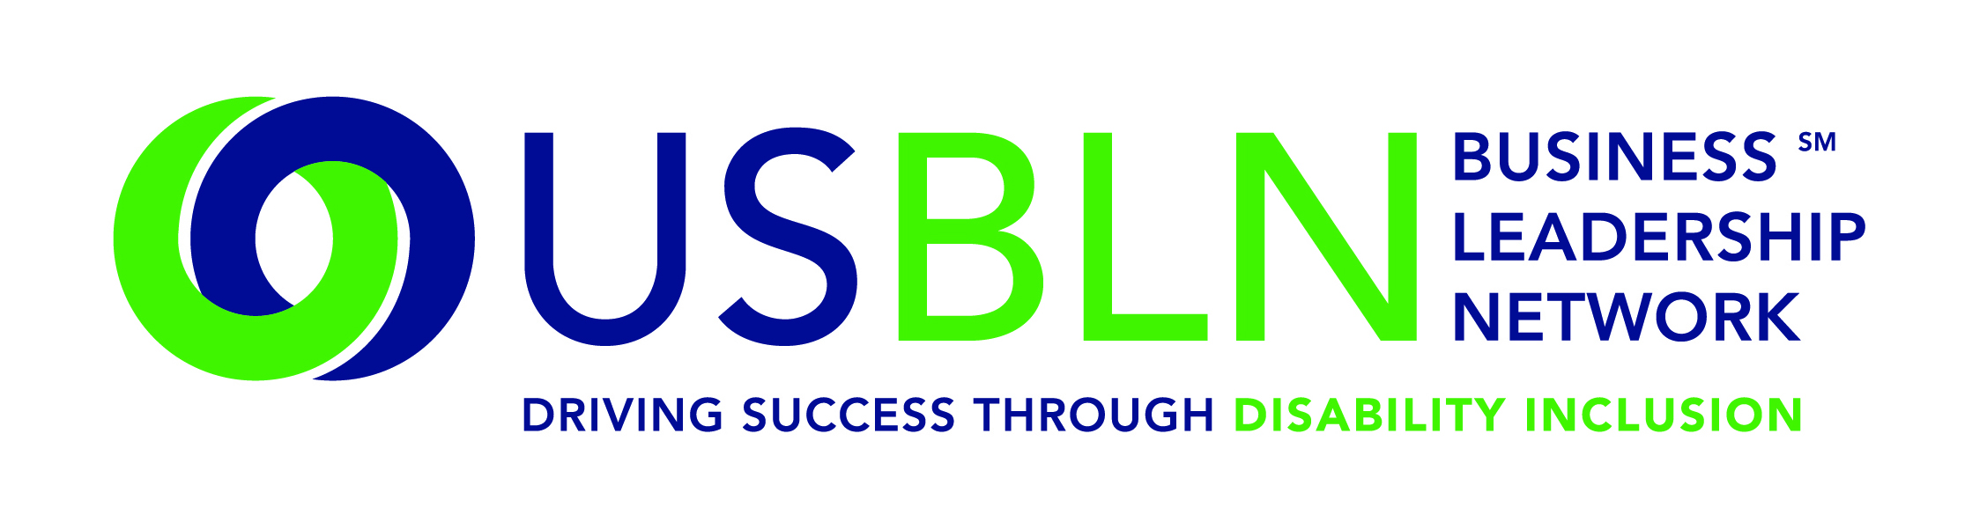

2014 USBLN 17th Annual National Conference & Biz2Biz Expo
Success in Orlando, Florida

For Immediate Release Contact: Anita Howard
October 2, 2014 Phone: (800) 706-2710 anita@usbln.org

WASHINGTON, DC (October 2, 2014) – The US Business Leadership Network® (USBLN®) 17th Annual National Conference & Biz2Biz Expo held in Orlando, Florida at the Renaissance Orlando at SeaWorld hotel on September 29-October 2 was a resounding success with record breaking attendance of over 600 with nearly half as first time conference attendees.
“This conference is vital to our mission to ensure that people with disabilities are fully included and play an integral role in the workplace, supply chain and marketplace. Participants learned innovative disability employment practices; key information on including certified disability-owned businesses in their supply chains; as well as innovative disability marketing strategies from leaders in business and disability employment practice,” stated Jill Houghton, Executive Director of the USBLN. “The USBLN is a trusted advisor and the leading voice of business to business, government and the media regarding disability inclusion across the enterprise. We were thrilled to provide our valued attendees with unique opportunities to connect, network, share and learn from their peers throughout our community.”

The 2014 program was directed by Workplace Track Chair Belinda Reed Shannon, Vice President, Equality & Inclusion, GlaxoSmithKline (GSK); Supply Chain Track Chair Ronnette Smith, Developmental Club Manager-North Division, Market 20 Upstate New York, Sam's Club; and Marketplace Track Chair Apoorva N. Gandhi, Vice President, Multicultural Affairs, Marriott International, Inc. Our Program Planning Committee Chair was Lori Golden, Abilities Strategy Leader, Americas People Team, Ernst & Young, LLP. The inaugural Disability-Owned Business Enterprise (DOBE®) Host Committee Chair was Joyce A. Bender, Founder and CEO, Bender Consulting Services, Inc. Their dedication to the event directly supports the best practices in the employment, advancement and retention of people with disabilities.

The 2014 USBLN 17th Annual National Conference & Biz2Biz Expo highlights concluded with:
- Over 30 interactive educational sessions were led by private sector business experts including CEOs at Fortune 500 companies, employers on DiversityInc's 2014 Top 50 List, and representatives from disability employment programs such as EARN, JAN, Ticket to Work, and Vocational Rehabilitation;
- Attendees enjoyed enhanced networking, industry sectors, international, marketplace, and workplace-focused roundtables, interactive programming plus opportunities to meet USBLN® certified Disability-Owned Business Enterprises (DOBE®s);
- An interview-based Supply Chain Plenary highlighted discussions on Private and Public Sector Procurement, Connecting with Service-Disabled Veteran-Owned Businesses (SDVOBs) and Educational Institutions: Influencing Disability-Owned Business Enterprises (DOBE)/SDVOB Growth & Development followed by the announcement of the USBLN certified DOBE "2014 Entrepreneurial Idol" winner Marc Goldman, Principal, Damon Brooks Associates (DBA);
- The 2014 USBLN Annual Leadership Awards Dinner celebrating Leadership Award recipients that embody the highest ethical standards and disability inclusion values led by Master of Ceremonies, Keith P. Wiedenkeller, Chief People Officer, AMC Theatres, (Retired); President & CEO, Humane Society of Greater Kansas City; Chair, USBLN with the opening song by Jack D. Smith, Founder & President, Charlotte International Partners, Inc. DOBE Host Committee Member; plus guest speakers, J.T. (Ted) Childs, Jr., Vice President, Global Workforce Diversity, IBM (Retired), and Deborah Dagit, Chief Diversity Officer, Merck (Retired); President, Deb Dagit Diversity, LLC; and
- The high-energy Closing Session entitled, “Leveraging the Personal Power of Professionals with Disabilities” featured Elizabeth ONeal, Compensation and Benefits Specialist, Mazuma Credit Union as moderator; with keynotes Anupa Iyer, Esq., Assistant to Commissioner Chai Feldblum, EEOC and Donté Mickens, MSM-RMI, CPCU, ARe, CRM, Senior Financial Analyst, NCCI.

Save the Date for the 2015 USBLN 18th Annual National Conference & Biz2Biz Expo
Mark your calendar now for the 18th Annual USBLN Conference to be held in Austin, Texas on September 28-October 1, 2015 at the Renaissance Austin hotel. This event will kick-off National Disability Employment Awareness Month (NDEAM) and celebrate the 25th Anniversary of the signing of the Americans with Disabilities Act. Event details will be made available at: www.usblnannualconference.org.

About the US Business Leadership Network (USBLN)
The US Business Leadership Network (USBLN) is a national non-profit that helps business drive performance by leveraging disability inclusion in the workplace, supply chain, and marketplace. The USBLN serves as the collective voice of nearly 50 Business Leadership Network affiliates across the United States, representing over 5,000 businesses. Additionally, the USBLN Disability Supplier Diversity Program® (DSDP) is the nation’s leading third party certification program for disability-owned businesses, including businesses owned by service-disabled veterans. www.usbln.org

####

