
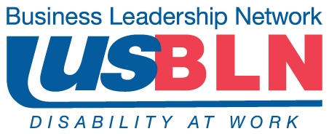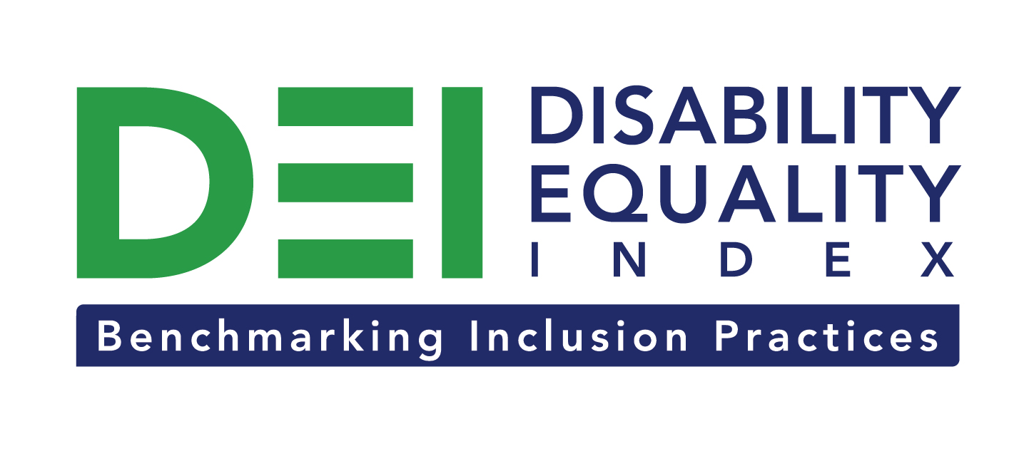

Disability Equality Index adds CVS Caremark as Founding Partner

Company Joins Comcast / NBCUniversal and New Editions Consulting, Inc. to support launch of online tool to measure businesses’ inclusion of people with disabilities

For Immediate Release Contact: Anita Howard
July 31, 2014 Phone: (800) 706-2710 anita@usbln.org

WASHINGTON, DC (July 31, 2014) – Today, the US Business Leadership Network® (USBLN®) and the American Association of People with Disabilities (AAPD) are are pleased to announce that CVS Caremark, the nation’s largest integrated pharmacy company, joined as a Founding Partner of the USBLN and AAPD’s new Disability Equality IndexSM (DEISM), an online tool that offers businesses the opportunity to objectively measure their full inclusion of people with disabilities as employees, suppliers, and customers.

“We are honored to have CVS Caremark join as a DEI Founding Partner,” said Jill Houghton, Executive Director of the USBLN. “By joining the DEI as a Founding Partner, CVS Caremark is showcasing their commitment to support disability inclusion in corporate America,” said Mark Perriello, President and CEO of AAPD.

Created by leaders in the business and disability communities, and after the successful completion of the DEI pilot with 48 Fortune 1000 companies in March 2014, the first Annual DEI will launch to Fortune 1000 companies in October 2014.

The DEI is a benchmarking tool that offers businesses the opportunity to receive an objective score on their disability inclusion policies and practices, and identify avenues for continued improvement. Companies self-report on a wide-range of criteria within four categories: Culture & Leadership, Enterprise-Wide Access, Employment Practices, and Community Engagement & Support Services.

“CVS Caremark is pleased to support the launch of the new Disability Equality Index (DEI), a tool that will provide companies the ability to monitor and refine their policies and practices for people with disabilities,” said David Casey, Vice President, Workforce Strategies, and Chief Diversity Officer for CVS Caremark. “As a company whose purpose is helping people on their path to better health, it is important for us to understand the health care needs of our customers, patients, plan members and colleagues, including those with disabilities. We are always looking for ways to enhance our services and we look forward to work with the DEI.”

CVS Caremark has a long-standing commitment to people with disabilities. One notable program, “Abilities in Abundance,” connects individuals with disabilities to fulfilling careers within CVS Caremark. To do so, CVS Caremark partners with vocational rehabilitation agencies, schools and non-profit organizations to identify talented individuals for roles in all areas of the business. In addition, the company has a Colleague Resource Group (CRG) for people with disabilities, which is aimed at fostering an inclusive, supportive environment that empowers all individuals with differing abilities.

The DEI Founding Partner status is a one-time opportunity exclusive to the first 15 companies that join before December 31, 2015. To date, DEI Founding Partners include CVS Caremark, Comcast and NBCUniversal, and New Editions Consulting, Inc. Companies interested in learning more about becoming a DEI Founding Partner should contact Liz Taub, USBLN Director, Business Relations & Strategic Partnerships, at liz@usbln.org.

For more information about the DEI, please visit: http://www.usbln.org/programs-dei.html.

About the US Business Leadership Network (USBLN)
The US Business Leadership Network (USBLN) is a national non-profit that helps business drive performance by leveraging disability inclusion in the workplace, supply chain, and marketplace. The USBLN serves as the collective voice of nearly 50 Business Leadership Network affiliates across the United States, representing over 5,000 businesses. Additionally, the USBLN Disability Supplier Diversity Program® (DSDP) is the nation’s leading third party certification program for disability-owned businesses, including businesses owned by service-disabled veterans. www.usbln.org

About the American Association of People with Disabilities (AAPD)
The American Association of People with Disabilities is the nation's largest disability rights organization. AAPD promotes equal opportunity, economic power, independent living, and political participation for people with disabilities. AAPD’s members, including people with disabilities and family, friends, and supporters, represent a powerful force for change. To learn more, visit the AAPD Web site: www.aapd.com.

# # #

