
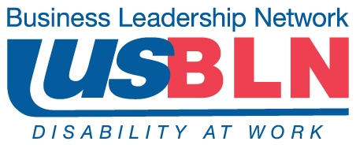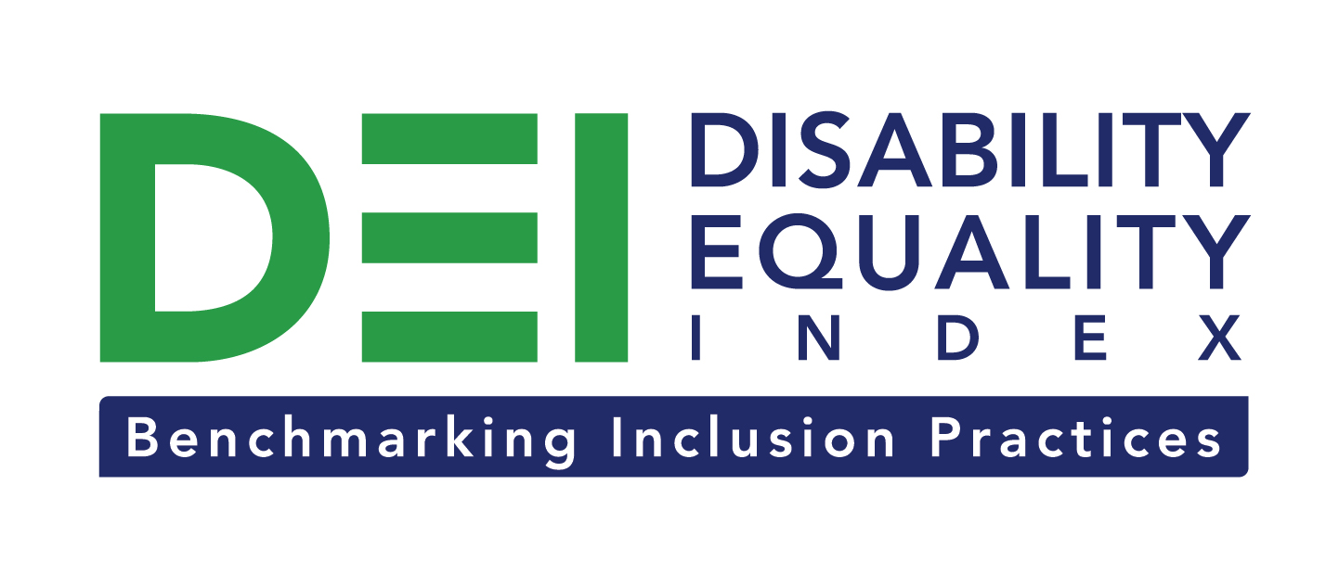

Comcast and NBCUniversal Help Launch Disability Equality Index

For Immediate Release Contact: Anita Howard
July 1, 2014 Phone: (800) 706-2710 anita@usbln.org

WASHINGTON, DC (July 1, 2014) – Today, the US Business Leadership Network® (USBLN®) and the American Association of People with Disabilities (AAPD) are pleased to announce that Comcast and NBCUniversal joined as the Founding Technology Partner of the USBLN and AAPD’s new Disability Equality IndexSM (DEISM), an online tool that offers businesses the opportunity to objectively measure their full inclusion of people with disabilities as customers, employees, and suppliers. Comcast and NBCUniversal’s Founding Partner funding will be used to build and power the technology underlying the DEI.

“By joining the DEI as the Founding Technology Partner, Comcast and NBCUniversal are showcasing their commitment to Americans with disabilities,” said Jill Houghton, Executive Director of the USBLN. “Comcast and NBCUniversal’s leadership is helping enable companies to utilize the DEI to educate themselves on best practices regarding people with disabilities in the workplace, supply chain, and marketplace.”

“We are very excited that Comcast and NBCUniversal have joined with AAPD and the USBLN to help launch the Disability Equality Index,” said Mark Perriello, President and CEO of AAPD, the nation’s largest disability rights organization. “With the help of Comcast and NBCUniversal, the DEI is positioned to be used for years to come to help advance the full inclusion of people with disabilities into the culture and practices of American business.”

Created by leaders in the business and disability communities, the DEI is a benchmarking tool that offers businesses the opportunity to receive an objective score, on a scale of zero to 100, on their disability inclusion policies and practices, and identify avenues for continued improvement. Companies self-report on a wide-range of criteria within four categories: Culture & Leadership, Enterprise-Wide Access, Employment Practices, and Community Engagement & Support Services.

The DEI Founding Partner status is a one-time opportunity exclusive to the first 15 companies who join before December 31, 2015. Donation levels start at $25,000. Those interested in learning more about becoming a DEI Founding Partner should contact Liz Taub, USBLN Director, Business Relations & Strategic Partnerships, at liz@usbln.org.

After the successful completion of the DEI pilot with 48 Fortune 1000 scope companies in March 2014, the USBLN and AAPD unveiled the first Annual DEI survey questions publicly for the first time on June 26, 2014. The first Annual DEI is scheduled to launch to Fortune 1000 companies in October 2014.

For more information about the DEI, please visit: http://www.neweditions.net/dei/.

Comcast and NBCUniversal have a history of commitment to people with disabilities. The company has a full-time team dedicated to making its products and services accessible to the widest possible audience with innovations such as the nation’s first talking cable TV interface, a dedicated customer support center for people with disabilities, and an Accessibility Product and Development Lab that serves as a workshop and showcase for assistive technologies.

About the US Business Leadership Network (USBLN)
The US Business Leadership Network (USBLN) is a national non-profit that helps business drive performance by leveraging disability inclusion in the workplace, supply chain, and marketplace. The USBLN serves as the collective voice of nearly 50 Business Leadership Network affiliates across the United States, representing over 5,000 businesses. Additionally, the USBLN Disability Supplier Diversity Program® (DSDP) is the nation’s leading third party certification program for disability-owned businesses, including businesses owned by service-disabled veterans. www.usbln.org

About the American Association of People with Disabilities (AAPD)
The American Association of People with Disabilities is the nation's largest disability rights organization. AAPD promotes equal opportunity, economic power, independent living, and political participation for people with disabilities. AAPD’s members, including people with disabilities and family, friends, and supporters, represent a powerful force for change. To learn more, visit the AAPD Web site: www.aapd.com.

# # #

