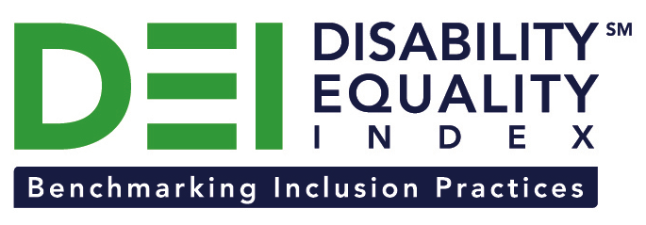

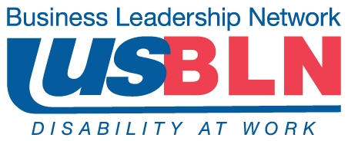

GSK Joins the Disability Equality Index as a Founding Partner

Company joins American Airlines, Comcast / NBCUniversal, CVS Health, and New Editions Consulting, Inc. to support launch of online tool to measure businesses’ inclusion of people with disabilities

For Immediate Release Contact: Anita Howard
September 18, 2014 Phone: (800) 706-2710 anita@usbln.org

WASHINGTON, DC (September 18, 2014) – Today, the US Business Leadership Network® (USBLN®) and the American Association of People with Disabilities (AAPD) are pleased to announce that GlaxoSmithKline (GSK) joined as a Founding Partner of the USBLN and AAPD’s new Disability Equality IndexSM (DEISM), an online tool that offers businesses the opportunity to objectively measure their full inclusion of people with disabilities as employees, suppliers, and customers. “We are thrilled to have GSK join us on this groundbreaking initiative for the business and disability communities,” said Jill Houghton, Executive Director of the USBLN. “As a DEI Founding Partner, GSK is showcasing their support of disability inclusive practices throughout corporate America,” said Mark Perriello, President and CEO of AAPD.

Created by leaders in the business and disability communities, and after the successful completion of the DEI pilot with 48 Fortune 1000 scope companies in March 2014, the first Annual DEI will launch to Fortune 1000 companies in October 2014.

The DEI is a benchmarking tool that offers businesses the opportunity to receive an objective score on their disability inclusion policies and practices, and identify avenues for continued improvement. Companies self-report on a wide-range of criteria within four categories: Culture & Leadership, Enterprise-Wide Access, Employment Practices, and Community Engagement & Support Services.

“We see the DEI as a fundamental tool for assessing how we’re doing in key categories and where we could do more to enable all of our employees to achieve their full potential,” said Belinda Shannon, Vice President, Equality & Inclusion, GSK.

The DEI Founding Partner status is a one-time opportunity exclusive to the first 15 companies that join before December 31, 2015. To date, DEI Founding Partners include American Airlines, Comcast and NBCUniversal, CVS Health, GSK, and New Editions Consulting, Inc. Companies interested in learning more about becoming a DEI Founding Partner should contact Liz Taub, USBLN Director, Business Relations & Strategic Partnerships, at liz@usbln.org.

For more information about the DEI, please visit: http://www.usbln.org/programs-dei.html.

About the US Business Leadership Network (USBLN)
The US Business Leadership Network (USBLN) is a national non-profit that helps business drive performance by leveraging disability inclusion in the workplace, supply chain, and marketplace. The USBLN serves as the collective voice of nearly 50 Business Leadership Network affiliates across the United States, representing over 5,000 businesses. Additionally, the USBLN Disability Supplier Diversity Program® (DSDP) is the nation’s leading third party certification program for disability-owned businesses, including businesses owned by service-disabled veterans. www.usbln.org

About the American Association of People with Disabilities (AAPD)
The American Association of People with Disabilities is the nation's largest disability rights organization. AAPD promotes equal opportunity, economic power, independent living, and political participation for people with disabilities. AAPD’s members, including people with disabilities and family, friends, and supporters, represent a powerful force for change. To learn more, visit the AAPD Web site: www.aapd.com.

# # #

