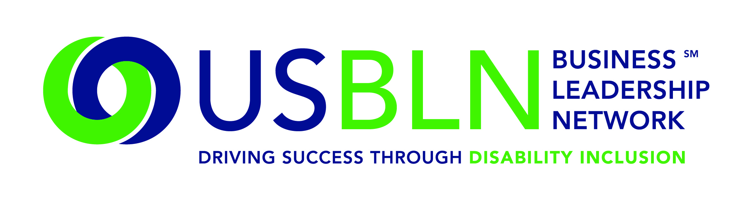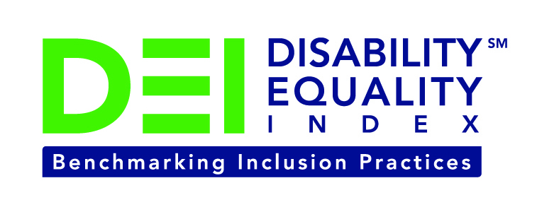

Lockheed Martin Joins the Disability Equality Index as a Founding Partner

Company joins American Airlines, Comcast / NBCUniversal, CVS Health, DuPont, GlaxoSmithKline, New Editions Consulting, Inc., Northrop Grumman Corporation, and WellPoint to support launch of online tool to measure businesses’ inclusion of people with disabilities

For Immediate Release Contact: Anita Howard
October 21, 2014 Phone: (800) 706-2710 anita@usbln.org

WASHINGTON, DC (October 21, 2014) – Today, the US Business Leadership Network® (USBLN®) and the American Association of People with Disabilities (AAPD) are pleased to announce that Lockheed Martin joined as a Founding Partner of the USBLN and AAPD’s new Disability Equality IndexSM (DEISM), an online tool that offers businesses the opportunity to objectively measure their full inclusion of people with disabilities as employees, suppliers, and customers.

“We are thrilled to have Lockheed Martin join us on this groundbreaking initiative for the business and disability communities,” said Jill Houghton, Executive Director of the USBLN. “By joining as a DEI Founding Partner, Lockheed Martin is showcasing their support of disability inclusive practices throughout corporate America,” said Mark Perriello, President and CEO of AAPD.

Created by leaders in the business and disability communities, and after the successful completion of the DEI pilot with 48 Fortune 1000 scope companies in March 2014, the first Annual DEI is launching to Fortune 1000 companies this month. More details can be found here: https://www.disabilityequalityindex.org/deisurvey/.

The DEI is a benchmarking tool that offers businesses the opportunity to receive an objective score on their disability inclusion policies and practices, and identify avenues for continued improvement. Companies self-report on a wide-range of criteria within four categories: Culture & Leadership, Enterprise-Wide Access, Employment Practices, and Community Engagement & Support Services.

“At Lockheed Martin, we’re committed to strengthening a culture of inclusion that allows employees to bring their entire selves to work every day and encourages them to contribute fully,” said Rainia Washington, vice president, Culture, Diversity and Equal Opportunity Programs. “We’re looking forward to partnering with DEI on this initiative to help organizations objectively review their disability practices and implement improvements.”

Lockheed Martin offers national and regional Leadership Forums that promote professional development, workplace inclusion and drive business results. Each forum is chaired by one or more Lockheed Martin senior executives and provides valuable networking, mentoring and leadership development opportunities. The People with Disabilities Leadership Forum was established in 2012 and aligns to the People with Disabilities Employee Resource Group.

The DEI Founding Partner status is a one-time opportunity exclusive to the first 15 companies that join before December 31, 2015. To date, DEI Founding Partners include American Airlines, Comcast / NBCUniversal, CVS Health, DuPont, GlaxoSmithKline, Lockheed Martin, New Editions Consulting, Inc., Northrop Grumman Corporation, and WellPoint. Companies interested in learning more about becoming a DEI Founding Partner should contact Liz Taub, USBLN Director, Business Relations & Strategic Partnerships, at liz@usbln.org.

For more information about the DEI, please visit: https://www.disabilityequalityindex.org/.

About the US Business Leadership Network (USBLN)
The US Business Leadership Network (USBLN) is a national non-profit that helps business drive performance by leveraging disability inclusion in the workplace, supply chain, and marketplace. The USBLN serves as the collective voice of nearly 50 Business Leadership Network affiliates across the United States, representing over 5,000 businesses. Additionally, the USBLN Disability Supplier Diversity Program® (DSDP) is the nation’s leading third party certification program for disability-owned businesses, including businesses owned by service-disabled veterans. www.usbln.org

About the American Association of People with Disabilities (AAPD)
The American Association of People with Disabilities is the nation's largest disability rights organization. AAPD promotes equal opportunity, economic power, independent living, and political participation for people with disabilities. AAPD’s members, including people with disabilities and family, friends, and supporters, represent a powerful force for change. To learn more, visit the AAPD Web site: www.aapd.com

####

