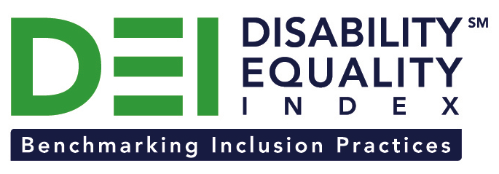

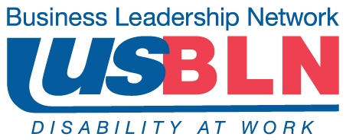

Northrop Grumman Joins the Disability Equality Index as a Founding Partner

Company joins American Airlines, Comcast / NBCUniversal, CVS Health, GlaxoSmithKline (GSK), and New Editions Consulting, Inc. to support launch of online tool to measure businesses’ inclusion of people with disabilities

For Immediate Release Contact: Anita Howard
September 23, 2014 Phone: (800) 706-2710 anita@usbln.org

WASHINGTON, DC (September 23, 2014) – Today, the US Business Leadership Network® (USBLN®) and the American Association of People with Disabilities (AAPD) are pleased to announce that Northrop Grumman Corporation, a leading global security company, joined as a Founding Partner of the USBLN and AAPD’s new Disability Equality IndexSM (DEISM), an online tool that offers businesses the opportunity to objectively measure their full inclusion of people with disabilities as employees, suppliers, and customers.

“Northrop Grumman’s commitment to hiring and retaining people with disabilities is leading the way,” said Jill Houghton, Executive Director of the USBLN. “We are thrilled to have Northrop Grumman join us on this incredible step forward for the disability and business communities,” said Mark Perriello, President and CEO of AAPD.

Created by leaders in the business and disability communities, and after the successful completion of the DEI pilot with 48 Fortune 1000 scope companies in March 2014, the first Annual DEI will launch to Fortune 1000 companies in October 2014.

The DEI is a benchmarking tool that offers businesses the opportunity to receive an objective score on their disability inclusion policies and practices, and identify avenues for continued improvement. Companies self-report on a wide-range of criteria within four categories: Culture & Leadership, Enterprise-Wide Access, Employment Practices, and Community Engagement & Support Services.

“Northrop Grumman is proud to be a DEI Founding Partner and is committed to a dynamic and inclusive environment for people with disabilities and veterans with disabilities,” said Sandra Evers-Manly, vice president, global corporate responsibility, Northrop Grumman, and president, Northrop Grumman Foundation. “We are doing this through a number of initiatives such as our award-winning Operation IMPACT program, which provides employment opportunities and career transition support to service members severely injured in combat.”

Operation IMPACT provides wounded service members with one-on-one personalized assistance in identifying potential job opportunities as well as marketing their skills to hiring managers and recruiters. The program has been instrumental in helping returning service personnel and their family members join the company. Additionally, Northrop Grumman recently launched a centralized accommodations function and has had an ongoing accessibility initiative in place for years.

The DEI Founding Partner status is a one-time opportunity exclusive to the first 15 companies that join before December 31, 2015. To date, DEI Founding Partners include American Airlines, Comcast and NBCUniversal, CVS Health, GSK, New Editions Consulting, Inc., and Northrop Grumman Corporation. Companies interested in learning more about becoming a DEI Founding Partner should contact Liz Taub, USBLN Director, Business Relations & Strategic Partnerships, at liz@usbln.org.

For more information about the DEI, please visit: http://www.usbln.org/programs-dei.html.

Northrop Grumman (NYSE: NOC) is a leading global security company providing innovative systems, products and solutions in unmanned systems, cyber, C4ISR, and logistics and modernization to government and commercial customers worldwide. Please visit www.northropgrumman.com for more information.

About the US Business Leadership Network (USBLN)
The US Business Leadership Network (USBLN) is a national non-profit that helps business drive performance by leveraging disability inclusion in the workplace, supply chain, and marketplace. The USBLN serves as the collective voice of nearly 50 Business Leadership Network affiliates across the United States, representing over 5,000 businesses. Additionally, the USBLN Disability Supplier Diversity Program® (DSDP) is the nation’s leading third party certification program for disability-owned businesses, including businesses owned by service-disabled veterans. www.usbln.org

About the American Association of People with Disabilities (AAPD)
The American Association of People with Disabilities is the nation's largest disability rights organization. AAPD promotes equal opportunity, economic power, independent living, and political participation for people with disabilities. AAPD’s members, including people with disabilities and family, friends, and supporters, represent a powerful force for change. To learn more, visit the AAPD Web site: www.aapd.com.

# # #

