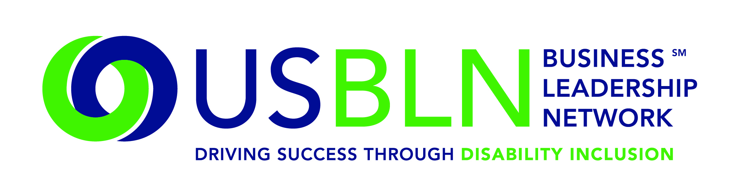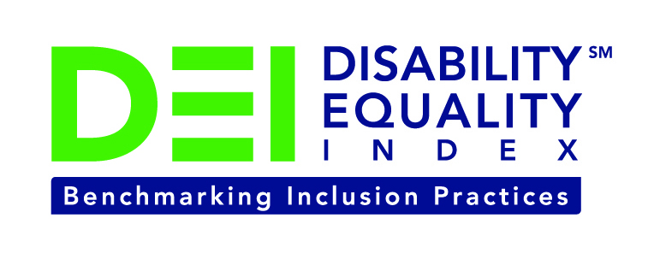

Raytheon Joins the Disability Equality Index as a Founding Partner

For Immediate Release Contact: Anita Howard
November 4, 2014 Phone: (800) 706-2710 anita@usbln.org

WASHINGTON, DC (November 4, 2014) – Today, the US Business Leadership Network® (USBLN®) and the American Association of People with Disabilities (AAPD) are pleased to announce that Raytheon joined as a Founding Partner of the USBLN and AAPD’s new Disability Equality IndexSM (DEISM), an online tool that offers businesses the opportunity to objectively measure their full inclusion of people with disabilities as employees, suppliers, and customers.

“We are thrilled to have Raytheon join us on this groundbreaking initiative for the business and disability communities,” said Jill Houghton, Executive Director of the USBLN. “By joining as a DEI Founding Partner, Raytheon is showcasing their support of disability inclusive practices throughout corporate America,” said Mark Perriello, President and CEO of AAPD.

Created by leaders in the business and disability communities, and after the successful completion of the DEI pilot with 48 Fortune 1000 scope companies in March 2014, the first Annual DEI was launched to Fortune 1000 companies in October 2014.

The DEI is a benchmarking tool that offers businesses the opportunity to receive an objective score on their disability inclusion policies and practices, and identify avenues for continued improvement. Companies self-report on a wide-range of criteria within four categories: Culture & Leadership, Enterprise-Wide Access, Employment Practices, and Community Engagement & Support Services.

“Being a Founding Partner of the DEI provides an opportunity to leverage effective practices in the employment and advancement of individuals with a disability,” said Hayward Bell, Raytheon Chief Diversity Officer. “Raytheon’s success depends on our ability to recognize, respect and leverage the individual and cultural differences of our workforce.”

“Our history of inclusiveness is key to our ability to attract and retain the best talent available,” said Rebecca Rhoads, Global Business Services president, Chief Information Officer and Executive Diversity Champion for Raytheon. “We are more effective as a company when our people reflect the diversity of our customers. It is a pathway to success for individuals and the company - for everyone, every day and everywhere.”

The DEI Founding Partner status was a one-time opportunity exclusive to the first 15 companies that joined. We’re excited to announce that the 15 spots have been filled. To date, DEI Founding Partners include American Airlines, CVS Health, DuPont, GlaxoSmithKline, Lockheed Martin, New Editions Consulting, Inc., Northrop Grumman Corporation, Raytheon, and WellPoint. The other DEI Founding Partners will be announced soon. Comcast / NBCUniversal is the DEI Exclusive Founding Technology Partner. Companies interested in learning more about other DEI opportunities should contact Liz Taub, USBLN Director, Business Relations & Strategic Partnerships, at liz@usbln.org.

For more information about the DEI, please visit: https://www.disabilityequalityindex.org/.

About the US Business Leadership Network (USBLN)
The US Business Leadership Network (USBLN) is a national non-profit that helps business drive performance by leveraging disability inclusion in the workplace, supply chain, and marketplace. The USBLN serves as the collective voice of nearly 50 Business Leadership Network affiliates across the United States, representing over 5,000 businesses. Additionally, the USBLN Disability Supplier Diversity Program® (DSDP) is the nation’s leading third party certification program for disability-owned businesses, including businesses owned by service-disabled veterans. www.usbln.org

About the American Association of People with Disabilities (AAPD)
The American Association of People with Disabilities is the nation's largest disability rights organization. AAPD promotes equal opportunity, economic power, independent living, and political participation for people with disabilities. AAPD’s members, including people with disabilities and family, friends, and supporters, represent a powerful force for change. To learn more, visit the AAPD Web site: www.aapd.com

####

