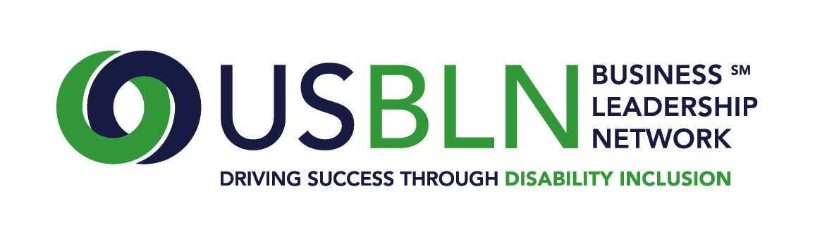
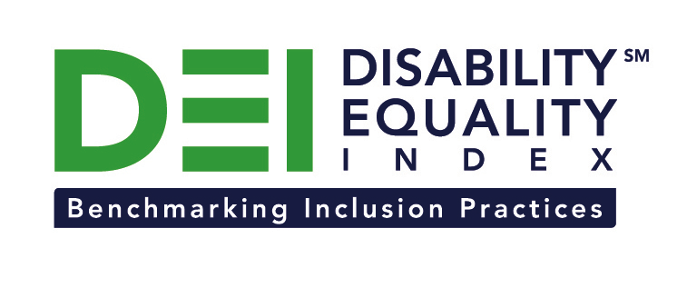

Walmart Joins the Disability Equality Index as a Founding Partner

Retailer demonstrates commitment to diversity and inclusion by joining other Fortune 1000 companies to support launch of online tool to measure enterprise-wide inclusion of people with disabilities

For Immediate Release Contact: Anita Howard
November 10, 2014 Phone: (800) 706-2710 anita@usbln.org

Washington, DC (November 10, 2014) -- Today, the US Business Leadership Network® (USBLN®) and the American Association of People with Disabilities (AAPD) are pleased to announce Walmart has joined as a Founding Partner of the USBLN and AAPD’s new Disability Equality IndexSM (DEISM), an online tool that offers businesses the opportunity to objectively measure their full inclusion of people with disabilities as employees, suppliers and customers.

“We are thrilled to have Walmart join us on this groundbreaking initiative for the business and disability communities. This is the latest development in a long-standing leadership position on disability inclusion,” said Jill Houghton, Executive Director of the USBLN. “By joining as a DEI Founding Partner, Walmart is showcasing their support of disability inclusive practices throughout corporate America,” said Mark Perriello, President and CEO of AAPD.

Created by leaders in the business and disability communities, and after the successful completion of the DEI pilot with 48 Fortune 1000 scope companies in March 2014, the first Annual DEI was launched to Fortune 1000 companies in October 2014.

Designed to serve as an objective benchmarking tool, the DEI offers businesses the opportunity to receive a score on their disability inclusion policies and practices while identifying avenues for continued improvement. Companies self-report on a wide-range of criteria within four categories: Culture & Leadership, Enterprise-Wide Access, Employment Practices, and Community Engagement & Support Services.

“As a global company we recognize disability is one of the few aspects of diversity that truly has no cultural, geographic or socioeconomic boundaries,” said Sharon Orlopp, Global Chief Diversity Officer and Senior Vice President – Corporate People for Walmart. “The DEI is a key resource helping companies examine their entire enterprise to identify best practices in diversity inclusion to become part of the broader corporate narrative while also isolating strategic opportunities for continuous improvement.”

In keeping with the spirit of advancing inclusion for people with disabilities around the world, Walmart has formally committed its support to the efforts centered on achieving Senate ratification of the United Nations Convention on the Rights of Persons with Disabilities (CRPD), also known as The Disability Treaty.

The DEI Founding Partner status was a one-time opportunity exclusive to the first 15 companies that joined. The USBLN and AAPD are excited to announce that the 15 spots have been filled. To date, DEI Founding Partners include American Airlines, CVS Health, DuPont, GlaxoSmithKline, Lockheed Martin, New Editions Consulting, Inc., Northrop Grumman Corporation, Raytheon, Walmart, and WellPoint. The other DEI Founding Partners will be announced soon. Comcast / NBCUniversal is the DEI Exclusive Founding Technology Partner. Companies interested in learning more about other DEI opportunities should contact Liz Taub, USBLN Director, Business Relations & Strategic Partnerships, at liz@usbln.org.

For more information about the DEI, please visit: https://www.disabilityequalityindex.org/.

About the US Business Leadership Network® (USBLN®)
The US Business Leadership Network® (USBLN®) is a national non-profit that helps business drive performance by leveraging disability inclusion in the workplace, supply chain, and marketplace. The USBLN® serves as the collective voice of over 50 Business Leadership Network affiliates across the United States, representing over 5,000 businesses. Additionally, the USBLN® Disability Supplier Diversity Program® (DSDP) is the nation’s leading third party certification program for disability-owned businesses, including businesses owned by service-disabled veterans. www.usbln.org

About the American Association of People with Disabilities (AAPD)
The American Association of People with Disabilities is the nation's largest disability rights organization. AAPD promotes equal opportunity, economic power, independent living, and political participation for people with disabilities. AAPD’s members, including people with disabilities and family, friends, and supporters, represent a powerful force for change. To learn more, visit the AAPD Web site: www.aapd.com.

####

