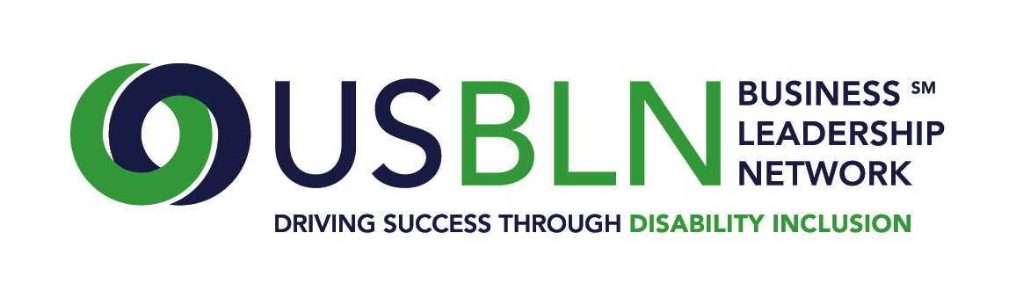
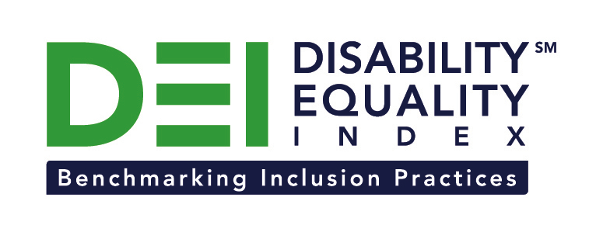

Highmark Inc. Joins the Disability Equality Index as a Founding Partner

For Immediate Release Contact: Anita Howard
November 25, 2014 Phone: (800) 706-2710 anita@usbln.org

Washington, DC (November 25, 2014) -- Today, the US Business Leadership Network® (USBLN®) and the American Association of People with Disabilities (AAPD) are pleased to announce that health insurer Highmark Inc. joined as a Founding Partner of the USBLN and AAPD's new Disability Equality IndexSM (DEISM), an online tool that offers businesses the opportunity to objectively measure their full inclusion of people with disabilities as employees, suppliers, and customers.
"We are thrilled to have Highmark Inc. join us on this groundbreaking initiative for the business and disability communities," said Jill Houghton, Executive Director of the USBLN. "By joining as a DEI Founding Partner, Highmark Inc. is showcasing its support of disability inclusive practices throughout corporate America," said Mark Perriello, President and CEO of AAPD.
Created by leaders in the business and disability communities, and after the successful completion of the DEI pilot with 48 Fortune 1000 scope companies in March 2014, the first Annual DEI was launched to Fortune 1000 companies in October 2014.
The DEI is a benchmarking tool that offers businesses the opportunity to receive an objective score on their disability inclusion policies and practices, and identify avenues for continued improvement. Companies self-report on a wide-range of criteria within four categories: Culture & Leadership, Enterprise-Wide Access, Employment Practices, and Community Engagement & Support Services.
"At Highmark, our employees are paramount to successfully serving our customers every day," said Deb Rice-Johnson, president of Highmark Health Plan and board member of the AAPD. "We strive for an inclusive culture, including recruiting and retaining people with disabilities. We are proud to continue to support the efforts of AAPD and the US Business Leadership Network. In particular, the new Disability Equality Index will help Highmark and other U.S. companies to meet higher, more consistent standards for inclusive workforces that embrace people with disabilities."
Added Sara Oliver-Carter, vice president of Diversity & Inclusion for Highmark Health, "The new Disability Equality Index is an important step forward. It will help Highmark and other companies to better create inclusive, high-performance workforces in which people with disabilities play vital roles."
The DEI Founding Partner status was a one-time opportunity exclusive to the first 15 companies that joined. The USBLN and AAPD are excited to announce that the 15 spots have been filled. To date, DEI Founding Partners include American Airlines, CVS Health, DuPont, GlaxoSmithKline, Highmark Inc., Lockheed Martin, New Editions Consulting, Inc., Northrop Grumman Corporation, Raytheon, Walmart, and WellPoint. The other DEI Founding Partners will be announced soon. Comcast / NBCUniversal is the DEI Exclusive Founding Technology Partner. Companies interested in learning more about other DEI opportunities should contact Liz Taub, USBLN Director, Business Relations & Strategic Partnerships, at liz@usbln.org.
For more information about the DEI, please visit: https://www.disabilityequalityindex.org/.

About the US Business Leadership Network® (USBLN®)
The US Business Leadership Network® (USBLN®) is a national non-profit that helps business drive performance by leveraging disability inclusion in the workplace, supply chain, and marketplace. The USBLN® serves as the collective voice of over 50 Business Leadership Network affiliates across the United States, representing over 5,000 businesses. Additionally, the USBLN® Disability Supplier Diversity Program® (DSDP) is the nation’s leading third party certification program for disability-owned businesses, including businesses owned by service-disabled veterans. www.usbln.org

About the American Association of People with Disabilities (AAPD)
The American Association of People with Disabilities is the nation's largest disability rights organization. AAPD promotes equal opportunity, economic power, independent living, and political participation for people with disabilities. AAPD’s members, including people with disabilities and family, friends, and supporters, represent a powerful force for change. To learn more, visit the AAPD Web site: www.aapd.com.

####

