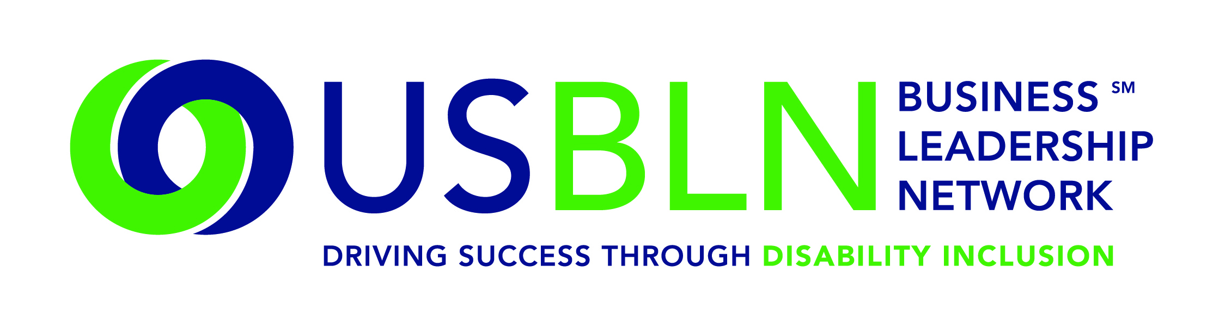

USBLN Announces 2014 Annual Leadership Award Winners

For Immediate Release Contact: Anita Howard
October 2, 2014 Phone: (800) 706-2710 anita@usbln.org

WASHINGTON, DC (October 2, 2014) – The US Business Leadership Network® (USBLN®) announced the winners of its 2014 Annual Leadership Awards, which were presented to the recipients on October 1st at the Leadership Awards Dinner during the 2014 USBLN 17th Annual National Conference & Biz2Biz Expo held in Orlando, Florida.
The purpose of the 2014 USBLN Annual Leadership Awards is to recognize leading disability workplace, supply chain and marketplace practices. Awardees demonstrate outstanding commitment to promoting disability inclusion across their enterprises and clearly embody the highest ethical standards and values in the community.

“Our 2014 Annual Leadership Award winners are outstanding individuals and organizations who are leading by example,” said Jill Houghton, USBLN Executive Director. “The awardees, selected through peer review, have achieved significant accomplishments that resulted in measurable and positive outcomes. We are proud that they are part of the USBLN family. “

AWARD CATEGORY WINNER

John D. Kemp Leadership Award: | Frances Wang West, Chief Accessibility Officer, IBM
Employer of the Year: | Starbucks Coffee Company
Top Corporation for Disability-Owned Business Enterprises: | Wells Fargo
Supplier of the Year: | Caption First, Inc., DOBE®
Affiliate of the Year: | Ohio Business Leadership Network (OHBLN)
Advocate of the Year-Supply Chain Inclusion: | Roxanne Wilson, Manager, Corporate Procurement, Supplier Diversity & Sustainability, Fannie Mae

The 2014 Annual Leadership Awards capped off yet another successful conference nearly 600 corporate, government, disability-owned businesses and BLN affiliates attending the conference.

Save the Date for the 2015 USBLN 18th Annual National Conference & Biz2Biz Expo
Mark your calendar now for the 18th Annual USBLN Conference to be held in Austin, Texas on September 28-October 1, 2015 at the Renaissance Austin hotel. This event will kick-off National Disability Employment Awareness Month (NDEAM) and celebrate the 25th Anniversary of the signing of the Americans with Disabilities Act. Event details will be made available at: www.usblnannualconference.org.

About the US Business Leadership Network (USBLN)
The US Business Leadership Network (USBLN) is a national non-profit that helps business drive performance by leveraging disability inclusion in the workplace, supply chain, and marketplace. The USBLN serves as the collective voice of nearly 50 Business Leadership Network affiliates across the United States, representing over 5,000 businesses. Additionally, the USBLN Disability Supplier Diversity Program® (DSDP) is the nation’s leading third party certification program for disability-owned businesses, including businesses owned by service-disabled veterans. www.usbln.org

####

