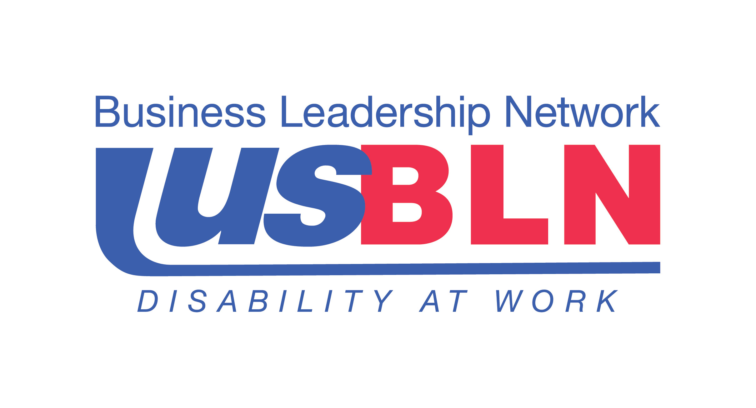

Nominations Now Being Accepted for the Coveted 2014 USBLN® Annual Leadership Awards

For Immediate Release Contact: Anita Howard
April 10, 2014 Phone: (800) 706-2710 anita@usbln.org

WASHINGTON, DC (April 10, 2014) – The US Business Leadership Network® (USBLN®) is pleased to announce the opening of the nomination process for their coveted 2014 USBLN® Annual Leadership Awards. The awards recognize leading disability workplace, supply chain and marketplace practices. Awardees demonstrate outstanding commitment to promoting disability diversity across their enterprises and clearly embody the highest ethical standards and values in the community.

“To more fully honor and recognize the proven practices and policies that demonstrate ongoing support for disability employment, marketing to customers with disabilities, and contracting with entrepreneurs with disabilities we have expanded our award categories this year. We are pleased to now accept nominations in the categories of Affiliate of the Year; Employer of the Year; Top Corporation for Disability-Owned Businesses; Advocate of the Year – Supply Chain Inclusion; and Supplier of the Year for 2014,” shared Jill Houghton, Executive Director, USBLN®.

The deadline for nominee submissions is May 16, 2014, at 5:00 pm EST. Companies are welcomed to self-nominate and may submit nominations for multiple categories for consideration; however, one form per category must be completed. Please submit nomination forms to: Cami Turcotte at cami@usbln.org. Note that late submissions will not be accepted.

Award recipients will be selected by committee and announced at the 2014 USBLN® 17th Annual National Conference & Biz2Biz Expo at a prestigious awards ceremony in Orlando, Florida, on October 1st. For more information or to register for the annual conference, visit: http://www.usblnannualconference.org

Nomination forms are available in Word document format via the links listed below for each category. Leaders in five (5) categories will be honored:

USBLN® Affiliate of the Year

The outstanding BLN Affiliate of the Year is one that has demonstrated exemplary efforts in promoting the vision, mission and spirit of the USBLN®. As a result of this BLN Affiliate’s efforts, employers and their communities understand, utilize, and benefit from the valuable resources that people with disabilities present in the workplace, supply chain and marketplace. [DOC]

USBLN® Employer of the Year

There are two categories for Employer of the Year award – one for companies with over 1000 employees and one for companies with less than 1000 employees. Companies are recognized for exemplary policies, strategies and initiatives that have resulted in measurable results in the areas of disability inclusiveness in the workplace, marketplace and supply chain. Note: Employer shall mean all employers except non-profit service providers and government agencies. [DOC]

USBLN® Top Corporation for Disability-Owned Businesses Award

The “Top Corporation for Disability-Owned Businesses” award is presented to the corporation or government agency that has demonstrated outstanding inclusion of USBLN® certified disability-owned businesses, including businesses owned by service disabled veteran-owned firms, and demonstrated commitment to disability business inclusion in their supply chain processes and corporate supplier diversity program. [DOC]

USBLN® Advocate of the Year – Supply Chain Inclusion

This award recognizes the individual advocate and/or procurement champion, who has provided exceptional support in the development of USBLN® certified Disability-Owned Business Enterprises- DOBE®s (including service-disabled veteran owned businesses) and the USBLN® Disability Supplier Diversity Program® (DSDP). The “Advocate of the Year-Supply Chain Inclusion” is someone who has demonstrated outstanding commitment to the utilization and growth of disability-owned businesses, including businesses owned by service-disabled veterans. [DOC]

USBLN® Supplier of the Year

This award recognizes the USBLN® certified Disability-Owned Business Enterprise (DOBE®) that has provided excellent service and distinguished itself and its business through its business practices and serves as a role model for disability business inclusion in the supply chain. Note: This category is designed for Business members to recognize disability suppliers in their supply chain. [DOC]

About the 2014 USBLN® 17th Annual National Conference & Bize2Biz Expo
The USBLN® will host their 17th Annual National Conference & Biz2Biz Expo entitled, "A Sea of Opportunity: Disability Inclusion for Innovation & Growth" in Orlando, Florida on September 29 - October 2. Early-bird registration is now open for this preeminent national business to business event that focuses on disability inclusion in the workplace, supply chain and marketplace. With cutting-edge educational sessions, enhanced networking, exciting interactive programming plus high-profile speakers, attendees will gain actionable knowledge to build a business case for their disability inclusion initiatives. www.usblnannualconference.org.

About the US Business Leadership Network® (USBLN®)
The US Business Leadership Network® (USBLN®) is a national non-profit that helps business drive performance by leveraging disability inclusion in the workplace, supply chain, and marketplace. The USBLN® serves as the collective voice of nearly 50 Business Leadership Network affiliates across the United States, representing over 5,000 businesses. Additionally, the USBLN® Disability Supplier Diversity Program® (DSDP) is the nation’s leading third party certification program for disability-owned businesses, including businesses owned by service-disabled veterans. www.usbln.org

# # #

