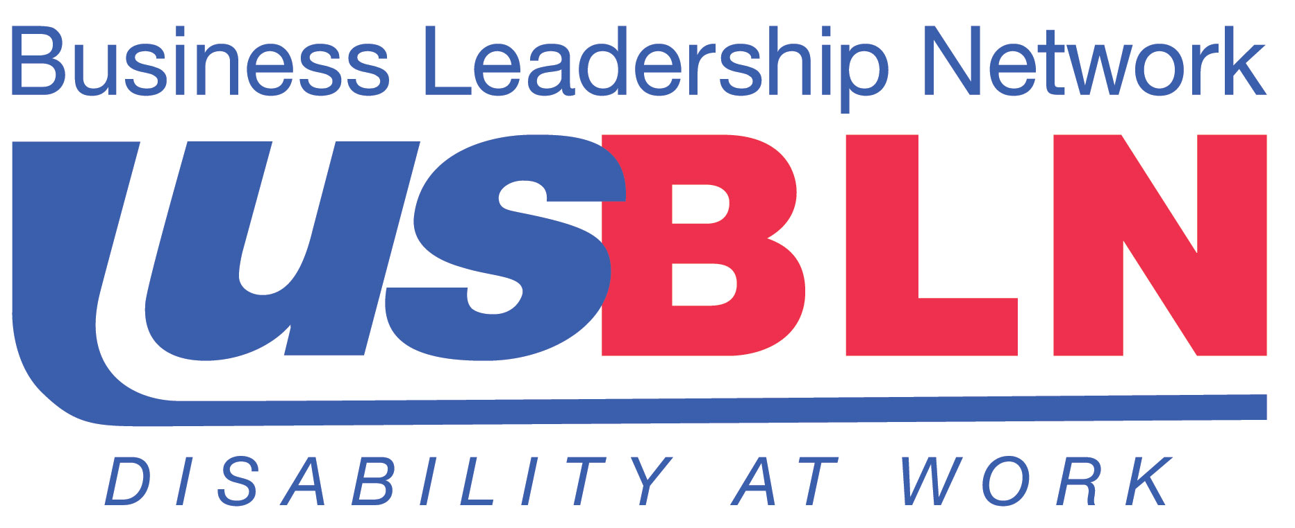

USBLN® Rebranding Input Committee Announced

Diverse Group of Stakeholders to Shape Organization’s Marketing Strategy

For Immediate Release Contact: Anita Howard
March 12, 2014 Phone: (800) 706-2710 anita@usbln.org

WASHINGTON, DC (March 12, 2014) – The US Business Leadership Network® (USBLN®) announced today the formation of their Rebranding Input Committee, a diverse group of key stakeholders who have assembled to share with the USBLN® their knowledge and expertise to help shape the organization’s marketing strategy, brand messaging and enhanced visual identity, including a new logo and tagline.

The USBLN® has made enormous strides in supporting their business members by raising awareness, providing education and promoting actions that result in increased inclusion of people with disabilities in workplaces, supply chains and marketplaces across the United States and in global communities. With the recent launch of their three-year strategic plan, a key objective is to rebrand the USBLN® to help achieve plan goals, and position the organization to become an even-more powerful and effective voice for disability inclusion.

The Committee’s members are:
David Bartage | Finance Manager, Tambrands Auburn, Procter & Gamble
Joyce A. Bender | President and CEO, Bender Consulting Services, Inc.
Susan Diegelman | Liaison to Disability Community, AT&T
Apoorva N. Gandhi | Vice President, Multicultural Markets and Alliances, Marriott International, Inc.
Erik A. Jenkins | Student, University of Illinois at Urbana-Champaign and USBLN® Student Advisory Council Member
Preety Kumar | President and CEO, Deque Systems Inc.
Chris Moranda, LSW, CDMS | Manager, Disability Services, Associate Health and Wellness, OhioHealth
Steve Pemberton | Chief Diversity Officer and Divisional Vice-President, Walgreen Co.
Gloria Pualani | Corporate Director, Socio-Economic Business Programs/Government Relations, Northrop Grumman Corporation
Roxanna Ritchey | Diversity & Inclusion Manager, Walt Disney Parks & Resorts
Michael Ronan | Regional Director, Channel Business Development, Latin America/Global Export, Starbucks Coffee Company
Keith P. Wiedenkeller, SPHR | Rebranding Input Committee Chair, SVP & Chief People Officer, American Multi-Cinema, Inc. (retired)

In addition to the formation of the Rebranding Input Committee, the organization is polling other members and stakeholders for their feedback to inform the process and to better understand their needs. These responses will form the basis of recommendations by the Committee and be submitted to Canyon Creative, the USBLN®’s partner Advertising Agency, to shape an impactful and memorable new visual identity.

“We look forward to the Rebranding Input Committee’s insights and perspectives, from leaders across different industries and within the disability community. We are honored to work with such a dynamic group of individuals who offer a broad range of backgrounds and viewpoints,” said Jill Houghton, Executive Director, USBLN®. “We are also thrilled to partner with Canyon Creative as our Advertising Agency. We are confident in their expertise to create a more meaningful brand for our organization that truly reflects who we are and will ultimately assist us in advancing opportunities for people with disabilities as employees, entrepreneurs and consumers across the nation.”

About the US Business Leadership Network® (USBLN®)
The US Business Leadership Network® (USBLN®) is a national non-profit that helps business drive performance by leveraging disability inclusion in the workplace, supply chain, and marketplace. The USBLN® serves as the collective voice of nearly 50 Business Leadership Network affiliates across the United States, representing over 5,000 businesses. Additionally, the USBLN® Disability Supplier Diversity Program® (DSDP) is the nation’s leading third party certification program for disability-owned businesses, including businesses owned by service-disabled veterans. www.usbln.org

About Canyon Creative
Canyon Creative is an award-winning Advertising Agency and Design Firm founded in 1996 with proficiency in branding, advertising, marketing, graphic design, website development, social media, packaging, environmental graphics, and retail product development. As Imaginative Strategists, they are experienced advertisers, designers, writers, creative thinkers, and web developers. Portfolio available at: http://canyoncreative.com.

# # #

