
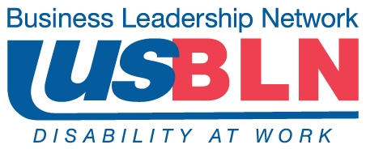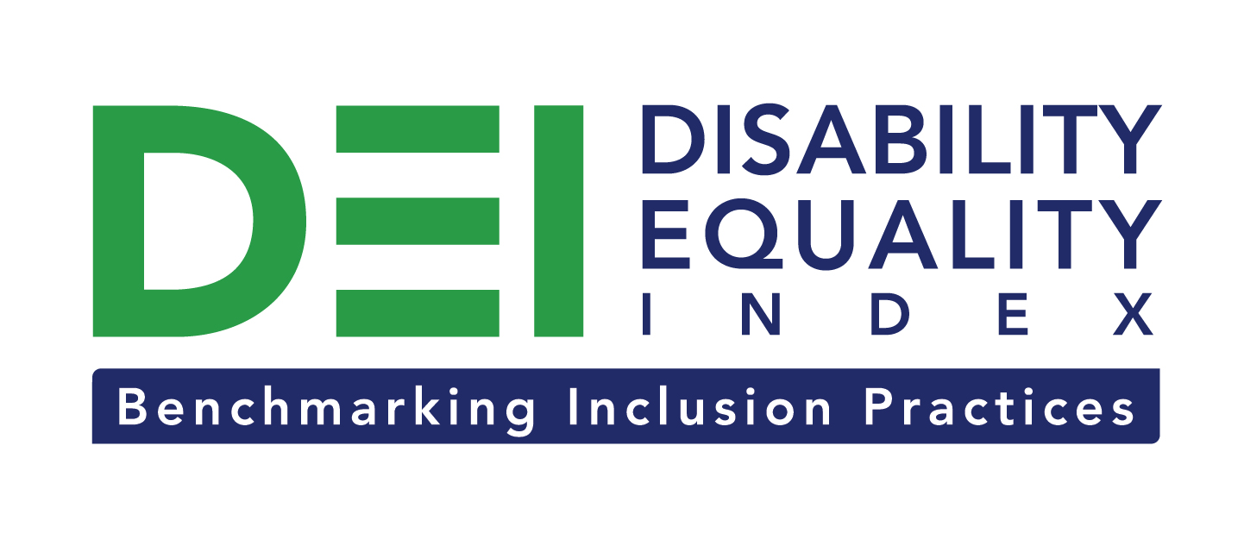

Registration Now Open for Disability Equality Index Survey

For Immediate Release Contact: Anita Howard
July 30, 2014 Phone: (800) 706-2710 anita@usbln.org

WASHINGTON, DC (July 30, 2014) – Today, the US Business Leadership Network® (USBLN®) and the American Association of People with Disabilities (AAPD) are excited to announce the opening of the registration process for the first Annual Disability Equality IndexSM (DEISM). Created by leaders in the business and disability communities, the DEI is an online benchmarking tool that offers businesses the opportunity to receive an objective score, on a scale of zero to 100, on their disability inclusion policies and practices.

The DEI is an aspirational, educational, recognition tool that is intended to help companies identify opportunities for continued improvement and help build a company’s reputation as an employer of choice.

After the successful completion of the DEI pilot with 48 Fortune 1000 scope companies in March 2014, the USBLN and AAPD invite Fortune magazine’s 1,000 largest publicly-traded businesses (the Fortune 1000) to participate in the October 2014 launch of the first Annual DEI. Other companies that are welcome to participate in the DEI include the following, providing they have 3,000 or more full-time employees in the U.S.:

- Private sector (non-government) employers that are not owned by a larger U.S. incorporated entity
- Businesses that serve as a U.S. subsidiary of a foreign-based multinational business
- Foreign-owned private companies on behalf of their U.S. operations

“Companies that participate in the DEI will be able to benchmark their progress year over year” said Jill Houghton, Executive Director of the USBLN. “The DEI is positioned to be used for years to come to help the business community and disability community,” said Mark Perriello, President and CEO of AAPD.

Eligible companies interested in participating in the first Annual DEI must register by October 24, 2014. To register, view the first Annual DEI Survey questions, or view DEI FAQs, visit here: https://disabilityequalityindex.org/deisurvey.

All registered companies will receive access to the first Annual DEI Survey tool in late October 2014. Reponses will then be due back in February 2015. DEI Survey scores will be finalized by April 2015.

Companies that take the DEI self-report on a wide-range of criteria within four categories: Culture & Leadership, Enterprise-Wide Access, Employment Practices, and Community Engagement & Support Services.

About the US Business Leadership Network (USBLN)
The US Business Leadership Network (USBLN) is a national non-profit that helps business drive performance by leveraging disability inclusion in the workplace, supply chain, and marketplace. The USBLN serves as the collective voice of nearly 50 Business Leadership Network affiliates across the United States, representing over 5,000 businesses. Additionally, the USBLN Disability Supplier Diversity Program® (DSDP) is the nation’s leading third party certification program for disability-owned businesses, including businesses owned by service-disabled veterans. www.usbln.org

About the American Association of People with Disabilities (AAPD)
The American Association of People with Disabilities is the nation's largest disability rights organization. AAPD promotes equal opportunity, economic power, independent living, and political participation for people with disabilities. AAPD’s members, including people with disabilities and family, friends, and supporters, represent a powerful force for change. To learn more, visit the AAPD Web site: www.aapd.com.

# # #

