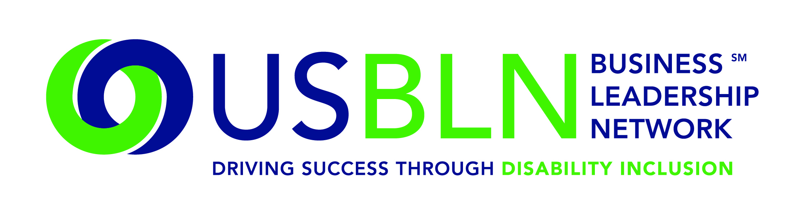

USBLN Members Honor Veterans with Disabilities on Veterans’ Day 2014
by Advancing Employment Opportunities

For Immediate Release Contact: Anita Howard
November 11, 2014 Phone: (800) 706-2710 anita@usbln.org

WASHINGTON, DC (November 11, 2014) – As the country honors all who served on this Veterans Day, the US Business Leadership Network® (USBLN®) thanks their member companies for their commitment to fully including veterans with disabilities in the workforce.
During 2014, employees from USBLN member companies volunteered to mentor college and university student veterans and recent graduates with disabilities through the USBLN Career Link Mentoring Program. Sixteen percent (16%) of the mentees were veterans with disabilities. These veterans were sourced through the Workforce Recruitment Program (WRP) in partnership with Cornell University's Employment & Disability Institute and were typically matched with mentors who are veterans. This program is supported by a grant from the Mitsubishi Electric America Foundation and the Walmart Foundation.

The USBLN looks forward to partnering with Cornell on a new program that Cornell is launching in 2015. The Veteran Career Transitions Mentoring Program, a collaborative project between Cornell University and the USBLN, is designed to provide support for veterans with disabilities seeking to move from the military into the civilian workforce. Tailored after the successful Career Link Mentoring Program and funded through seed money from the Blackstone Charitable Foundation, 30 mentors from the business community will be matched with 30 veterans with disabilities.

The USBLN is pleased to provide two additional benefits for USBLN member companies to help them advance inclusion of veterans, including veterans with disabilities. The USBLN's Disability Supplier Diversity Program is expanding efforts to market to Service Disabled Veteran Owned Businesses (SDVOBs) to become part of a growing number of disability entrepreneurs who vie for commercial contract opportunities with USBLN corporate members. To start the process, SDVOBs are encouraged to apply for USBLN certification and visit their website at http://www.usbln.org/sdvob.html for detailed information. The USBLN’s November Members Only Webinar, “Veterans with Disabilities: Creating Inclusive Workplaces,” is scheduled for November 19, 2014. Presenters are Karen Stang, Operation IMPACT Program Administrator, Northrop Grumman Corporation and Ron Drach, a combat injured Viet Nam veteran and President of Drach Consulting.

About the US Business Leadership Network (USBLN)
The US Business Leadership Network (USBLN) is a national non-profit that helps business drive performance by leveraging disability inclusion in the workplace, supply chain, and marketplace. The USBLN serves as the collective voice of nearly 50 Business Leadership Network affiliates across the United States, representing over 5,000 businesses. Additionally, the USBLN Disability Supplier Diversity Program® (DSDP) is the nation’s leading third party certification program for disability-owned businesses, including businesses owned by service-disabled veterans. www.usbln.org

####

