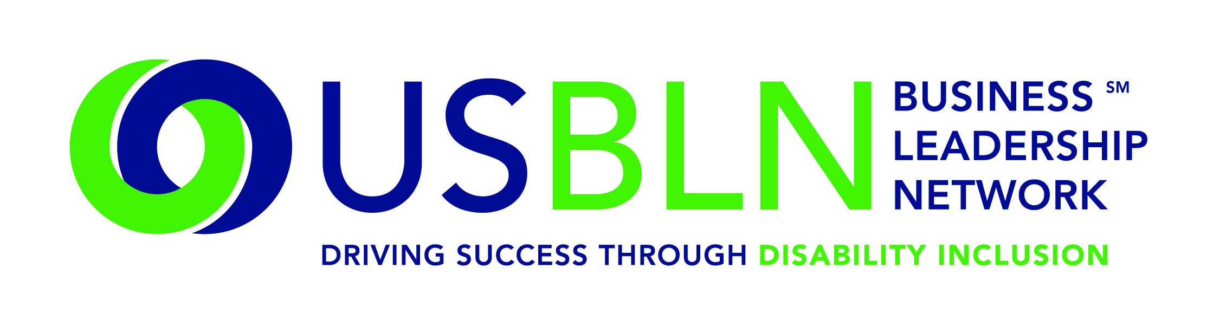
American Airlines Helps Launch America's First Disability Rights Museum on Wheels
For Immediate Release Contact: Shawna Berger
June 30, 2015 Phone: (800) 706-2710 shawna@usbln.org
WASHINGTON, D.C. (June 30, 2015) - Today, the US Business Leadership Network® (USBLN®) officially announced American Airlines has come on board as a Tour Partner of America's Disability Rights Museum on Wheels (DRMW), the country's first disability rights mobile museum.
DRMW is an accessible self-contained motor vehicle, featuring interactive learning opportunities and emerging technologies to assist those with disabilities. The mobile museum cross-country tour began June 8, 2015, in Charlotte, N.C., and continues through 2016. The DRMW provides a unique opportunity to learn the fascinating history of the disability rights movement. It presents an eye-catching exhibit that invites the visitor to participate in hands-on learning about the disability civil rights movement and the technological innovation as a result of the Americans with Disabilities Act (ADA).
“As an airline committed to meeting the needs of our customers with disabilities, it is our privilege to partner with the USBLN on this first ever, one-of-a-kind opportunity to advance awareness and education around the ADA and what it means for all Americans,” said Mike Waldron, Managing Director Diversity & Inclusion, American Airlines. “The learning opportunities provided by the DRMW are significant and American Airlines is honored to be a part of this historic endeavor.”
Together, the ADA Legacy Project and the DRMW are aligning communities with a vision that bridges the legacy of the ADA and the next 25 years.
Specifically, the DRMW is designed to help local communities:
- Understand that the ADA is a Civil Rights law
- Engage youth in interactive learning experiences
- Educate the public on the history of human rights violations and the community engagement that led up to the passage of the ADA
- Promote public awareness through social media, filmed interviews and stories with members of the disability and business communities
- Discover the possibilities during the next 25 years through experiencing innovative and connective technologies
- Provide business, education, government, and communities with tools for promoting full inclusion within their organizations
Locations have been identified by their proximity to geographic target markets of USBLN corporate members. The markets include: Washington, D.C., Los Angeles, Chicago, Atlanta, Charlotte, New York, San Francisco and Seattle. Additionally, tour stops are aligned with several of the nation's most prominent ADA celebrations under development.

Upcoming stops in 2015 include:

- July 8: PNC Park, Pittsburgh, Pa.
- July 14: CUNY John Jay College of Criminal Justice, New York City
- July 18: Legislative Mall, Dover, Del.
- July 21: Museum Campus (adjacent to Soldier’s Field), Chicago, Ill.
- July 26: Smithsonian American History Museum- Festival ADA: 25 Years of Disability Rights, Washington, D.C.
- July 31: U.S. Chamber of Commerce, Washington, D.C.
- September 14-15: Klyde Warren Park, Dallas, Texas
- September 17: Houston, Texas
- September 28-October 1: USBLN® National Conference & Expo, Austin, Texas
- October 7: Boehringer Ingelheim HQ, Ridgefield, Conn.
- October 2015: Windsor, Conn.
- October 12-13: Times Square, New York City
- October 20: Bentonville, Ark.
- November 7-8: Loyola Marymount University, Los Angeles, Calif.

Proposed stops in 2016 include:
- Philadelphia, Pa.
- Anderson, S.C.
- May 2016: Seattle, Wash.
- May 2016: San Francisco, Calif.
- September 20 – 22: USBLN® National Conference & Expo, Orlando, Fla.
For more information about sponsoring the DRMW, please contact Liz Taub at liz@usbln.org.
DRMW Presenting and Tour Sponsors
A special thank you to EY and Wells Fargo for stepping in as Presenting Partners of America's Disability Rights Museum on Wheels and to American Airlines, The Loreern Arbus Foundation, Boehringer Ingelheim, Cigna, Cox Communications, GlaxoSmithKline, JPMorgan Chase & Co., Miami Trailer, Microsoft, Northrop Grumman Corporation, PNC Bank, Walgreens Boots Alliance, and Walmart for sponsoring America's Disability Rights Museum on Wheels as Tour Partners.

About the US Business Leadership Network (USBLN)
The US Business Leadership Network (USBLN) is a national non-profit that helps business drive performance by leveraging disability inclusion in the workplace, supply chain, and marketplace. The USBLN serves as the collective voice of nearly 50 Business Leadership Network affiliates across the United States, representing over 5,000 businesses. Additionally, the USBLN Disability Supplier Diversity Program® (DSDP) is the nation's leading third party certification program for disability-owned businesses, including businesses owned by service-disabled veterans. www.usbln.org

About The ADA Legacy Project and Tour
The Tour is a traveling exhibit rolling across the country raising awareness and building excitement toward ADA25 - the 25th anniversary of the ADA. The ADA Legacy Tour is inspired by the historic 50- state journey taken by the husband-and-wife team of Justin and Yoshiko Dart in 1988 to garner grassroots support for the yet-to-be-passed Americans with Disabilities Act. www.roadtofreedom.net
####

