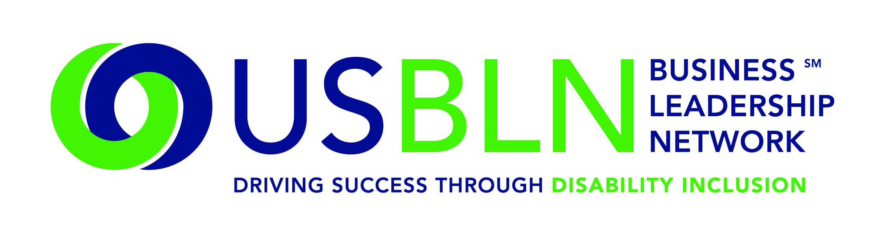

EY Helps Launch America's First Disability Rights Museum on Wheels

For Immediate Release Contact: Anita Howard
May 7, 2015 Phone: (800) 706-2710 anita@usbln.org
WASHINGTON, DC (May 7, 2015) – Today, the US Business Leadership Network® (USBLN®) officially announced that EY has secured the remaining Presenting Partner opportunity of America's Disability Rights Museum on Wheels, the country's first disability rights mobile museum.
America's Disability Rights Museum on Wheels (DRMW), an accessible self-contained motor vehicle, features interactive learning opportunities and emerging technologies. The mobile museum will kick off its cross-country tour June 8, 2015 in Charlotte, NC. The DRMW provides a unique opportunity to learn the fascinating history of the disability rights movement. It presents an eye-catching exhibit that invites the visitor to participate in hands-on learning about the disability civil rights movement and the technological innovation as a result of the Americans with Disabilities Act (ADA).
"We are also thrilled to announce that Stephen R. Howe, Jr., Americas Managing Partner and Managing Partner of the U.S. firm, Ernst & Young, LLP, joins Senator Tom Harkin, Senator Bob Dole, and Congressman Tony Coelho on the DRMW Honorary Board of Advisors,” said Jill Houghton, Executive Director of the USBLN. Other distinguished members of the DRMW Advisory Board include senior executives from USBLN member companies and a cross section of respected leaders with a demonstrated background in furthering the ADA's goal of equality for people with disabilities in the workplace and in society.
"I'm honored to serve alongside such respected leaders who were instrumental in the passing of the Americans With Disabilities Act of 1990 (ADA) and who remain focused on furthering the goal of equality for people of all abilities in the workplace,” said Howe. "One of our founders Arthur Young was deaf and had low vision. His differing abilities led him to become an entrepreneur and an innovator in the profession. At EY, we're proud to build on his legacy of leveraging the talents of people of all abilities."
Together, the ADA Legacy Project and America's Disability Rights Museum on Wheels are aligning communities with a vision that bridges the legacy of the ADA and the next 25 years.
Specifically, the DRMW is designed to help local communities:
- Understand that the ADA is a Civil Rights law
- Engage youth in interactive learning experiences
- Educate the public on the history of human rights violations and the community engagement that led up to the passage of the ADA
- Promote public awareness through social media, filmed interviews and stories with members of the disability and business communities
- Discover the possibilities during the next 25 years through experiencing innovative and connective technologies
- Provide business, education, government, and communities with tools for promoting full inclusion within their organizations
Locations have been identified by their proximity to geographic target markets of USBLN corporate members. The markets include, Washington, DC, Los Angeles, Chicago, Atlanta, Charlotte, New York, San Francisco and Seattle. Additionally, tour stops and are aligned with several of the nation's most prominent ADA Celebrations under development.
Identified stops in 2015 to date include:
- June 8-9: Wells Fargo Atrium, Charlotte, NC (official launch)
- June 11: Cox Enterprise Headquarters, Atlanta, GA
- June 12: Shepherd Center, Atlanta, GA
- June 13-15: Center for Civil Human & Rights, Atlanta, GA
- July 8-9: PNC Field, Pittsburgh, PA
- July 13-18: Chicago, IL
- July 26-31: Washington, DC
- September 14-15: Dallas, TX
- September 17-18: Houston, TX
- September 29-October 1: USBLN® 18th Annual National Conference & Expo, Austin, TX
- October 2015: Ridgefield, CT
- October 2015: NYC, NY
- November 2015: Los Angeles
For more information about sponsoring the DRMW, please contact Liz Taub at liz@usbln.org.
DRMW Presenting and Tour Sponsors
A special thank you to EY and Wells Fargo for stepping us as Presenting Partners of America's Disability Rights Museum on Wheels and to Boehringer Ingelheim, Cigna, Cox Communications, Northrop Grumman Corporation and PNC Bank for sponsoring America's Disability Rights Museum on Wheels as Tour Partners.
About the US Business Leadership Network (USBLN)
The US Business Leadership Network (USBLN) is a national non-profit that helps business drive performance by leveraging disability inclusion in the workplace, supply chain, and marketplace. The USBLN serves as the collective voice of nearly 50 Business Leadership Network affiliates across the United States, representing over 5,000 businesses. Additionally, the USBLN Disability Supplier Diversity Program® (DSDP) is the nation’s leading third party certification program for disability-owned businesses, including businesses owned by service-disabled veterans. www.usbln.org

About The ADA Legacy Project and Tour
The Tour is a traveling exhibit rolling across the country raising awareness and building excitement toward ADA25 - the 25th anniversary of the ADA. The ADA25 Legacy Tour is inspired by the historic 50- state journey taken by the husband-and-wife team of Justin and Yoshiko Dart in 1988 to garner grassroots support for the yet-to-be-passed Americans with Disabilities Act. www.roadtofreedom.net

####

