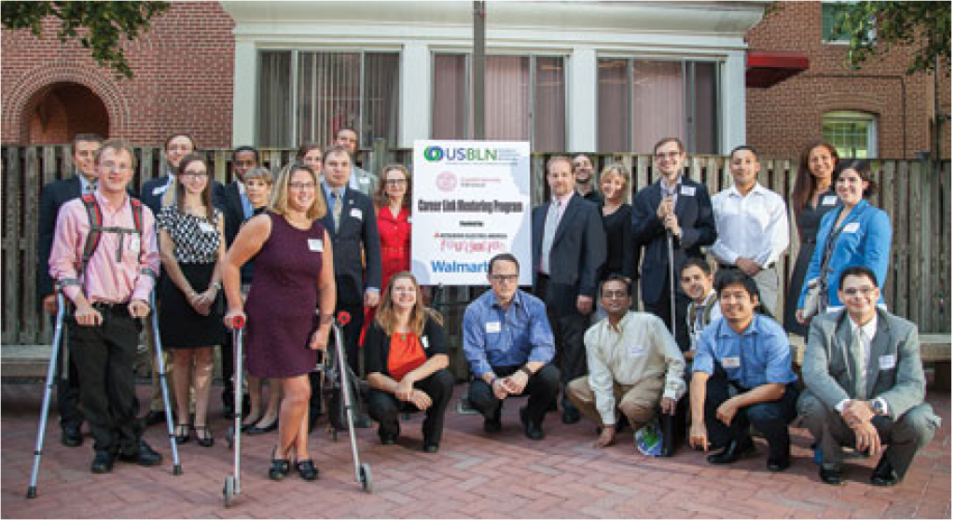

USBLN Plays Matchmaker for Companies That See Value in Disability Inclusion

by Alexandra Vollman
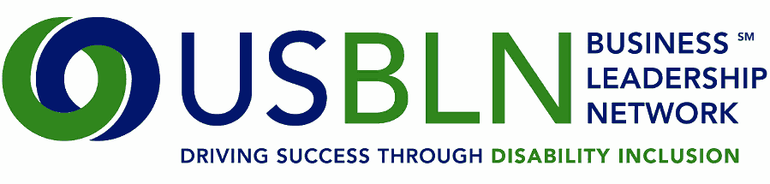
In the United States, an estimated 57 million people live with a disability. Of these, 19.5 percent who are of working age are employed, while 10.2 percent are still actively seeking employment, according to the most recent U.S. Department of Labor data.

[Above: Participants in USBLN’s Career Link Mentoring Program at a reception in Washington, D.C., in August]

The U.S. Business Leadership Network (USBLN) - a national nonprofit organization that helps businesses drive performance by leveraging disability inclusion in the workplace, supply chain, and marketplace - helps create and foster opportunities for employees with disabilities and for people with disabilities who own small businesses.

Serving as the collective voice of nearly 50 BLN affiliates nationwide and representing more than 5,000 businesses, USBLN helps connect corporations that are members of the organization with smaller businesses that are 51 percent or more owned, operated, controlled, and managed by individuals with disabilities. As the nation’s leading third-party certifier for disability-owned businesses - including those owned by service-disabled veterans - USBLN serves as the intermediary between these companies and corporations seeking to expand their supplier diversity programs.

Through this certification, called the Disability Supplier Diversity Program, corporations gain access to shared best practices and diverse suppliers, and disability-owned businesses gain access to contracting opportunities and learn how to compete more effectively for contracts.

The organization also promotes disability inclusion through its Career Link Mentoring Program, a collaborative project with Cornell University’s Employment and Disability Institute. Through this six-month program, the organization matches mentors from USBLN member companies with college students and recent graduates - including veterans - who have disabilities.

“I think there’s so much that can be learned from people with disabilities and from people who don’t have disabilities - and [their] working together. These are people who want to work and who have something to give. It’s a win-win for businesses, and it’s a win-win for people with disabilities,” says Shawna Berger, director of marketing and communications for USBLN.

Supported in part by grants from the Mitsubishi Electric America Foundation and the Wal-Mart Foundation, the program saw an increase of more than 250 percent in student participants this year from its pilot year, with 72 mentees representing 55 colleges and universities across the country.

In addition to its Career Link Mentoring Program, USBLN advances disability inclusion in myriad ways. Its Going for Gold project goes one step further by matching college graduates who have disabilities with businesses seeking diverse employees. USBLN’s goal is for 190 people with a disability to be employed at each participating company within the next three years, for a total of 1,140 people hired.

“We often hear from companies that they can’t find the talent they’re looking for, and we hear from job seekers that they can’t find companies to work for, so in essence, we’re kind of playing the matchmaker,” Berger says.

With October being National Disability Employment Awareness Month, USBLN is taking to the streets with the first-ever Disability Rights Museum on Wheels, which is currently touring the country. The organization created the museum in partnership with the ADA Legacy Project to review and celebrate 25 years of the Americans with Disabilities Act.

Alexandra Vollman is the editor of INSIGHT Into Diversity. For more information about U.S. Business Leadership Network, visit usbln.org.

