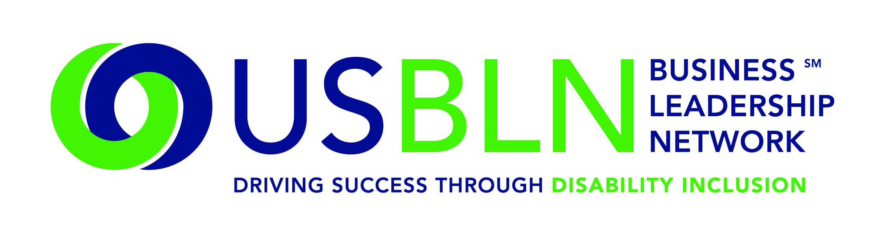
USBLN and Marriott International Team Up for Disability Innovation
Innovation Lab Tests Concepts for Guests with Disabilities

For Immediate Release Contact: Shawna Berger
Phone: (800) 706-2710
WASHINGTON, D.C. (Oct. 30, 2015) – Travel is a critical component for advancement in many careers. Individuals with disabilities often face obstacles that seem insignificant to most travelers. This was the catalyst for the US Business Leadership Network® (USBLN®) and Marriott International to partner together during a recent innovation design lab tour and feedback session. Held at Marriott’s innovation lab in Bethesda, Md., a group of business travelers and individuals met to discuss Marriott’s new accessibility ideas and experiences for travelers with disabilities.

“Marriott strives to create a welcoming experience for travelers with disabilities and we were excited to partner with them on this innovative and first-of-its-kind project,” said Jill Houghton, executive director, USBLN. “Marriott believes that hosting guests with disabilities starts with making a reservation, and recognizes the value of a business-to-business partnership in addressing issues and developing creative solutions for disability inclusion.”

Participants engaged in a design thinking approach to create a better travel experience for travelers with disabilities. The time spent at the Marriott International Innovation Lab revealed opportunities early in the customer journey to
- Know Me: when possible, personalize my booking to my specific needs.
- Show Me: present the properties and services that best match my needs.
- Tell me: confirm (or say no) to my need requests in advance of travel, allowing me to better plan.

Input and themes from the session are part of an ongoing partnership to build in better travel experiences for everyone at the design stage of development. Participants also experienced design enhancements of room and common area concepts and gave insightful first-hand feedback about room usability and design.

"Putting people first" has always been part of Marriott's DNA. We believe our core strength lies in our ability to embrace differences and create opportunities for employees, guests, owners and franchisees, and suppliers. We want to make sure we welcome all travelers and that our hotels are accessible and inclusive to ensure a great stay,” said David Rodriguez, Executive Vice President, Human Resources and Chief Diversity Officer, Marriott International.

“People with Disabilities are natural innovators and we need to bring that lens to our designs to ensure that our hotels are accessible for all,” said Matthew Von Ertfelda, Vice President, Insights, Strategy and Innovation, Marriott International.

The US Business Leadership Network (USBLN)
The US Business Leadership Network (USBLN) is a national non-profit that helps business drive performance by leveraging disability inclusion in the workplace, supply chain, and marketplace. The USBLN serves as the collective voice of nearly 50 Business Leadership Network affiliates across the United States, representing over 5,000 businesses. Additionally, the USBLN Disability Supplier Diversity Program® (DSDP) is the nation’s leading third party certification program for disability-owned businesses, including businesses owned by service-disabled veterans.

Marriott International
Marriott International, Inc. (NASDAQ: MAR) is a global leading lodging company based in Bethesda, Maryland, USA, with more than 4,300 properties in 81 countries and territories. Marriott International reported revenues of nearly $14 billion in fiscal year 2014. The company operates and franchises hotels and licenses vacation ownership resorts under 19 brands. For more information or reservations, please visit our website at www.marriott.com, and for the latest company news, visit www.marriottnewscenter.com.
###

