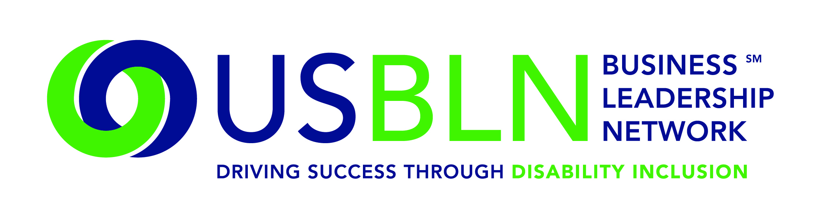

USBLN Announces the Formation of a Procurement Council

For Immediate Release Contact: Anita Howard
February 9, 2015 Phone: (800) 706-2710 anita@usbln.org

WASHINGTON, DC (February 9, 2015) – The US Business Leadership Network®’s (USBLN®’s) Disability Supplier Diversity Program® (DSDP) has made steady and continuous progress in supporting inclusion of disability and service-disabled veteran-owned businesses in supply chains with the help of the original 15 founding partners. Since 2010, the DSDP has enjoyed the added support of corporations who have joined as members and aided in the development and utilization of suppliers within the disability community.

The Procurement Council will hold its first teleconference meeting on Wednesday, February 11,
10-11:15 a.m. EST. The formation of the Council sets the stage and allows for informed input from corporate members and gives member corporations a voice in building advocacy. The Procurement will work closely with the USBLN and DSDP team.

“We look forward to the Procurement Council’s insights and perspectives, from leaders across different industries and within the disability community. We are appreciative and confident in their expertise and grateful for their service as champions of the forward-movement of the DSDP and its activities,” said Jill Houghton, USBLN Executive Director.

Each USBLN member company may avail themselves of a seat on the Procurement Council as part of their benefits package with one individual designated as their representative. There are currently 23 companies on the Council listed below. Representatives are passionate about disability inclusion and may be selected from internal departments such as supplier diversity, diversity and inclusion, supply chain and employee resource groups, etc.

2015 USBLN® Procurement Council Corporate Member Companies

AIG | CVS Health | Comcast
EY, LLP | Fannie Mae | Humana
IBM | Lockheed Martin | Marriott
Merck | Novartis Pharmaceuticals | Office Depot/OfficeMax
PNC Bank | Prudential | PWC, LLP
Sanofi | Sodexo | Southwest Airlines
Takeda Pharmaceuticals USA | TD Bank | Time Warner
UPS | Walgreens

If you are interested in joining them and would like more information about the Procurement Council, please contact Cami Turcotte, cami@usbln.org or Patricia Richards, patricia@usbln.org.

About the US Business Leadership Network (USBLN)
The US Business Leadership Network (USBLN) is a national non-profit that helps business drive performance by leveraging disability inclusion in the workplace, supply chain, and marketplace. The USBLN serves as the collective voice of nearly 50 Business Leadership Network affiliates across the United States, representing over 5,000 businesses. Additionally, the USBLN Disability Supplier Diversity Program® (DSDP) is the nation’s leading third party certification program for disability-owned businesses, including businesses owned by service-disabled veterans. www.usbln.org

####

