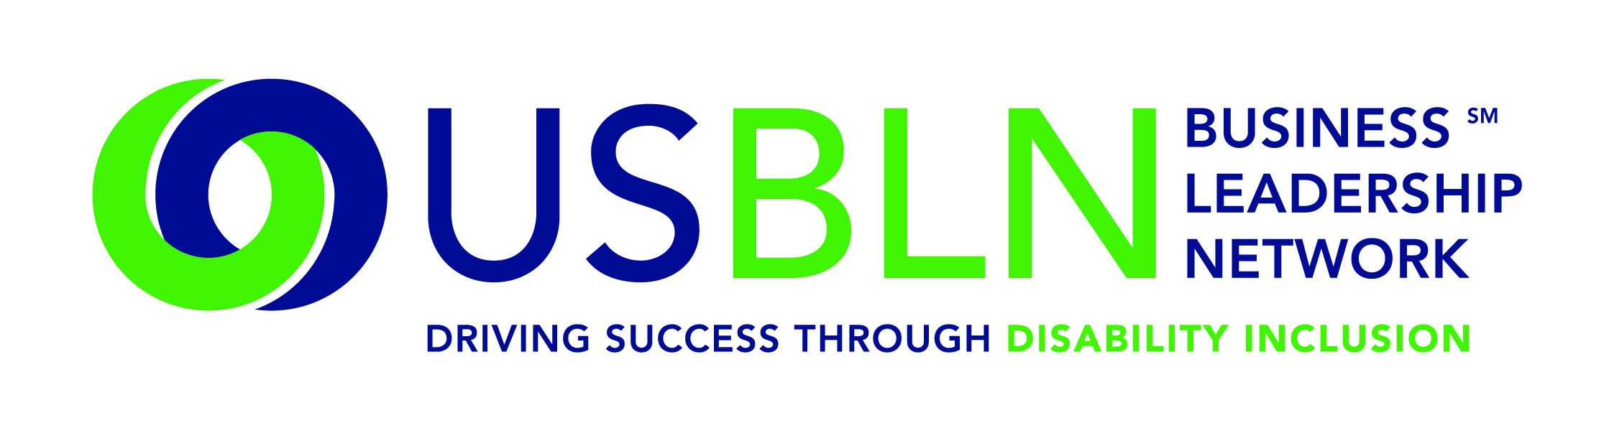

USBLN and Wells Fargo Officially Launch America's First
Disability Rights Museum on Wheels
America's first disability rights mobile museum opens in Charlotte, NC on June 8, 2015

For Immediate Release Contact: Anita Howard, USBLN
June 3, 2015 (800) 706-2710 anita@usbln.org

Lisa Westermann, Wells Fargo & Company
(415) 845-7759
lisa.b.westermann@wellsfargo.com

WASHINGTON, DC (June 3, 2015) – The US Business Leadership Network® (USBLN®) and Wells Fargo & Company (NYSE: WFC) today announced the launch of America's Disability Rights Museum on Wheels, the country's first disability rights mobile museum.

To commemorate the launch, Wells Fargo and USBLN will host a two-day event that will kick off in Charlotte, NC on June 8, 2015 at the Wells Fargo Atrium with remarks and speeches by distinguished guests. Immediately following the opening event, attendees and dignitaries will be invited to tour America's Disability Rights Museum on Wheels (DRMW), which will be located at Levine Avenue of the Arts through June 9 for tours before embarking on a cross-country tour leading into 2016.

"At Wells Fargo, we are committed to serving customers and team members with disabilities, and we are proud to support this museum. As a Presenting Partner, we are honored to be part of this historic occasion to celebrate the legacy of the disability rights movement," said Kathy Martinez, People With Disabilities Segment manager at Wells Fargo.
America's Disability Rights Museum on Wheels is an accessible self-contained motor vehicle that features interactive learning opportunities and emerging technologies. The DRMW provides a unique opportunity to learn the fascinating history of the disability rights movement. It presents an eye-catching exhibit that invites the visitor to participate in hands-on learning about the disability civil rights movement and the technological innovation as a result of the Americans with Disabilities Act (ADA).

The museum will also be joined by the ADA Legacy Tour, a national bus tour that has traveled more than 14,000 miles commemorating the 25th anniversary of the Americans with Disabilities Act.

The ADA Legacy Tour has brought attention to communities across the country about the importance of preserving the past; educating future advocates; and celebrating the present milestones and accomplishments of disability rights. The ADA Legacy Tour, hosted by the ADA Legacy Project, will conclude in Washington, DC on July 26, the day the ADA became law in 1990.

"We are also thrilled to announce our collaborative partnership with the ADA Legacy Project," said Jill Houghton, Executive Director of the USBLN. "The ADA's relatively quick passage was greatly facilitated by an unprecedented grass roots movement throughout the country. The ADA Legacy Project and Tour pays tribute to the cross-disability movement that led to the passage of the ADA."

Together, the ADA25 Legacy Project and America's Disability Rights Museum on Wheels are aligning communities with a vision that bridges the legacy of the ADA and the next 25 years.

Specifically, the DRMW is designed to help local communities:
- Understand that the ADA is a Civil Rights law
- Engage youth in interactive learning experiences
- Educate the public on the history of human rights violations and the community engagement that led up to the passage of the ADA
- Promote public awareness through social media, filmed interviews and stories with members of the disability and business communities
- Discover the possibilities during the next 25 years through experiencing innovative and connective technologies
- Provide business, education, government, and communities with tools for promoting full inclusion within their organizations
Locations have been identified by their proximity to geographic target markets of USBLN corporate members. The markets include Washington, D.C., Los Angeles, Chicago, Atlanta, Charlotte, New York, San Francisco and Seattle. Additionally, tour stops are aligned with several of the nation's most prominent ADA Celebrations under development. Identified stops in 2015 to date include:
- June 8-9: Charlotte, NC (official launch)
- June 11: Cox Enterprise Headquarters, Atlanta, GA
- June 12: Shepherd Center, Atlanta, GA
- June 13-15: Center for Civil & Human Rights, Atlanta, GA
- July 8-9: PNC Park, Pittsburgh, PA
- July 18: Dover, Delaware
- July 21: Chicago, IL(tentative)
- July 26: Smithsonian Museum of American History, Washington, DC (tentative)
- July 31: U.S. Chamber of Commerce, Washington, D.C.
- September 14-15: Klyde Warren Park, Dallas, TX
- September 17-18: Houston, TX
- September 29-October 1: USBLN National Conference & Expo, Austin, TX
- October 2015: Ridgefield, CT
- October 2015: NYC, NY
- November 7-8, 2015: Loyola Marymount University, Los Angeles, CA
For information about sponsoring the DRMW, please contact Liz Taub at liz@usbln.org.

DRMW Presenting and Tour Sponsors
A special thank you to EY and Wells Fargo for stepping up as Presenting Partners of America's Disability Rights Museum on Wheels and to Boehringer Ingelheim, Cigna, Cox Communications, GSK, Microsoft, Northrop Grumman Corporation, PNC Bank, Walgreens and Walmart for sponsoring America's Disability Rights Museum on Wheels as Tour Partners.

About the US Business Leadership Network (USBLN)

The US Business Leadership Network (USBLN) is a national non-profit that helps business drive performance by leveraging disability inclusion in the workplace, supply chain, and marketplace. The USBLNserves as the collective voice of nearly 50 Business Leadership Network affiliates across the United States, representing over 5,000 businesses. Additionally, the USBLN Disability Supplier Diversity Program® (DSDP) is the nation's leading third party certification program for disability-owned businesses, including businesses owned by service-disabled veterans. www.usbln.org

About The ADA Legacy Project and Tour

The Tour is a traveling exhibit rolling across the country raising awareness and building excitement toward ADA25 - the 25th anniversary of the ADA. The ADA Legacy Tour is inspired by the historic 50- state journey taken by the husband-and-wife team of Justin and Yoshiko Dart in 1988 to garner grassroots support for the yet-to-be-passed Americans with Disabilities Act. www.roadtofreedom.net

About Wells Fargo & Company

Wells Fargo & Company (NYSE: WFC) is a nationwide, diversified, community-based financial services company with $1.7 trillion in assets. Founded in 1852 and headquartered in San Francisco, Wells Fargo provides banking, insurance, investments, mortgage, and consumer and commercial finance through more than 8,700 locations, 12,500 ATMs, and the internet (wellsfargo.com) and mobile banking, and has offices in 36 countries to support customers who conduct business in the global economy. With approximately 266,000 team members, Wells Fargo serves one in three households in the United States. Wells Fargo & Company was ranked No. 29 on Fortune's 2014 rankings of America's largest corporations. In 2014, Wells Fargo donated $281.2 million in grants to 17,100 nonprofits, and team members volunteered 1.74 million hours around the country. Wells Fargo's vision is to satisfy all our customers' financial needs and help them succeed financially. Wells Fargo perspectives are also available at Wells Fargo Blogs and Wells Fargo Stories.

####

