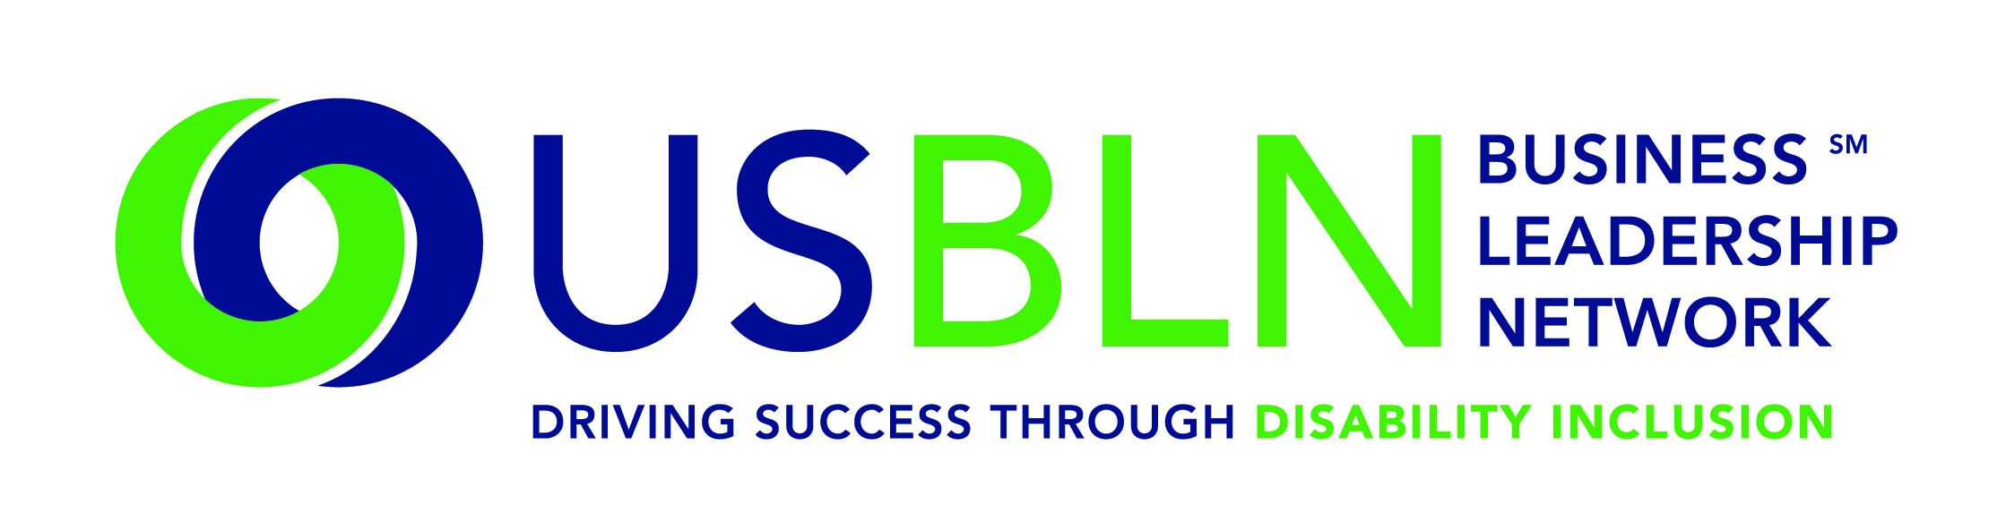
Valued Partners,

Today is a historic day for disability-owned businesses and service-disabled owned businesses! Earlier this morning Massachusetts Governor Charlie Baker announced several improvements to the state’s supplier diversity program, including best practice innovations and updates from the public and private sectors, the first expansion of benchmarks for minority and women-owned businesses in four years, and the first-time certification of veteran, disability and LGBT-owned businesses.

The Baker-Polito Administration’s policy changes and inclusiveness of new supplier diversity categories and partnerships, have also been made effective in a Governor’s Executive Order signed today, reaffirming and expanding the Supplier Diversity Program.

What does this mean for the USBLN?
- First-time certification of disability-owned business enterprises (DOBE), which will also conduct certifications of service-disabled, veteran-owned business enterprises (SDVOBE).
- Expanding the certified SDVOBE category of the Supplier Diversity Program to include all certified veteran-owned business enterprises (VBE), continuing to use the federal VetBiz certification process (and new partnership with the USBLN for the certification of SDVOBEs), at a combined, existing benchmark of 3 percent.
- Acceptance of the USBLN certification for disability-owned businesses sends a clear message that state government is welcoming people with disabilities and incentivizing opportunities that promote self-determination.
- The changes to the Massachusetts’ Supplier Diversity Program include improvements to the state’s small and diverse business certification and reporting processes and cross-certification partnerships with the City of Boston and nationally-recognized private certification organizations.

Economic self-sufficiency through jobs or business ownership is a key way to strengthen America’s economy and our communities. We applaud Governor Baker for taking this momentous next step to include disability-owned business enterprises, which includes service-disabled veteran-owned business enterprises and LGBT-owned businesses.

We are excited and grateful to be a part of such a historic event. We look forward to working with the Commonwealth of Massachusetts, and for this to be the model for the rest of the country. There are an estimated 57 million Americans with disabilities and around 15 percent of working persons with disabilities are self-employed. Our disability-owned business enterprises and service-disabled veteran-owned business certification processes will help many businesses into the supplier diversity pipeline.

Juntos Podemos (Together We Can)!
