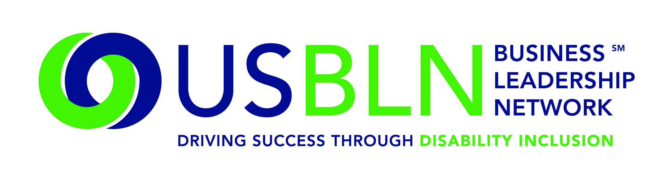
Cigna Helps Launch America's First Disability Rights Museum on Wheels
For Immediate Release Contact: Anita Howard
May 26, 2015 Phone: (800) 706-2710 anita@usbln.org

WASHINGTON, DC (May 26, 2015) - Today, the US Business Leadership Network® (USBLN®) officially announced that Cigna, a global health services company with programs designed to help people with disabilities return to health and life, has come on board as a Tour Partner of America's Disability Rights Museum on Wheels, the country's first disability rights mobile museum.

America's Disability Rights Museum on Wheels (DRMW), an accessible self-contained motor vehicle, features interactive learning opportunities and emerging technologies to assist those with disabilities. The mobile museum will kick off its cross-country tour June 8, 2015 in Charlotte, NC. The DRMW provides a unique opportunity to learn the fascinating history of the disability rights movement. It presents an eye-catching exhibit that invites the visitor to participate in hands-on learning about the disability civil rights movement and the technological innovation as a result of the Americans with Disabilities Act (ADA).

“The America's Disability Rights Museum on Wheels is an important part of helping people understand that individuals with different abilities are active and engaged members of the workforce,” said Mark Marsters, senior vice president of operations for Cigna's disability benefits business. “It’s also an important and visual reminder for companies and hiring managers that the best, most productive and qualified employee may be someone with a disability.”
Together, the ADA Legacy Project and America's Disability Rights Museum on Wheels are aligning communities with a vision that bridges the legacy of the ADA and the next 25 years.
Specifically, the DRMW is designed to help local communities:
- Understand that the ADA is a Civil Rights law
- Engage youth in interactive learning experiences
- Educate the public on the history of human rights violations and the community engagement that led up to the passage of the ADA
- Promote public awareness through social media, filmed interviews and stories with members of the disability and business communities
- Discover the possibilities during the next 25 years through experiencing innovative and connective technologies
- Provide business, education, government, and communities with tools for promoting full inclusion within their organizations

Locations have been identified by their proximity to geographic target markets of USBLN corporate members. The markets include, Washington, DC, Los Angeles, Chicago, Atlanta, Charlotte, New York, San Francisco and Seattle. Additionally, tour stops and are aligned with several of the nation's most prominent ADA Celebrations under development.

Identified stops in 2015 to date include:
- June 8-9: Wells Fargo Atrium, Charlotte, NC (official launch)
- June 11: Cox Enterprise Headquarters, Atlanta, GA
- June 12: Shepherd Center, Atlanta, GA
- June 13-15: Center for Civil Human & Rights, Atlanta, GA
- July 8: PNC Park, Pittsburgh, PA
- July 18: Dover, DE
- July 21: Chicago, IL
- July 31: US Chamber of Commerce Washington, DC
- September 14-15: Klyde Warren Park, Dallas, TX
- September 17-18: Houston, TX
- September 29-October 1: USBLN® 18th Annual National Conference & Expo, Austin, TX
- October 2015: Ridgefield, CT
- October 13-15: Times Square, NYC, NY
- November 7-8 2015: Loyola Marymount University, Los Angeles
For more information about sponsoring the DRMW, please contact Liz Taub at liz@usbln.org.
DRMW Presenting and Tour Sponsors
A special thank you to EY and Wells Fargo for stepping us as Presenting Partners of America's Disability Rights Museum on Wheels and to Boehringer Ingelheim, Cigna, Cox Communications, GlaxoSmithKline, Northrop Grumman Corporation, PNC Bank, and Walmart for sponsoring America's Disability Rights Museum on Wheels as Tour Partners.

About the US Business Leadership Network (USBLN)
The US Business Leadership Network (USBLN) is a national non-profit that helps business drive performance by leveraging disability inclusion in the workplace, supply chain, and marketplace. The USBLN serves as the collective voice of nearly 50 Business Leadership Network affiliates across the United States, representing over 5,000 businesses. Additionally, the USBLN Disability Supplier Diversity Program® (DSDP) is the nation's leading third party certification program for disability-owned businesses, including businesses owned by service-disabled veterans. www.usbln.org

About The ADA Legacy Project and Tour
The Tour is a traveling exhibit rolling across the country raising awareness and building excitement toward ADA25 - the 25th anniversary of the ADA. The ADA Legacy Tour is inspired by the historic 50- state journey taken by the husband-and-wife team of Justin and Yoshiko Dart in 1988 to garner grassroots support for the yet-to-be-passed Americans with Disabilities Act. www.roadtofreedom.net
####

