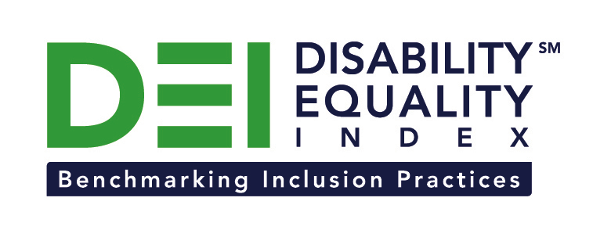
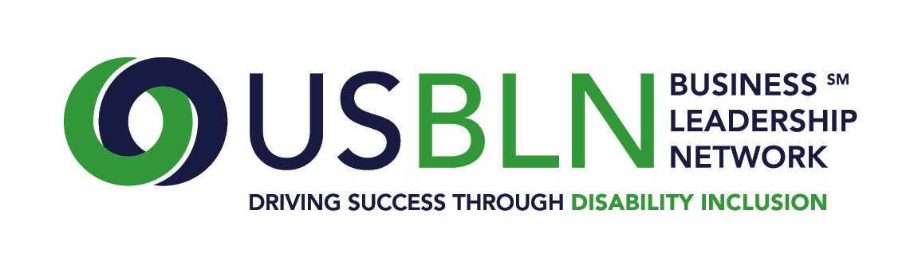

JPMorgan Chase & Co. Joins the Disability Equality Index as a Founding Partner

For Immediate Release Contact: Anita Howard
December 15, 2014 Phone: (800) 706-2710 anita@usbln.org

Washington, DC (December 15, 2014) – Today, the US Business Leadership Network® (USBLN®) and the American Association of People with Disabilities (AAPD) are pleased to announce that JPMorgan Chase & Co. joined as a Founding Partner of the USBLN and AAPD’s new Disability Equality IndexSM (DEISM), an online tool that offers businesses the opportunity to objectively measure their full inclusion of people with disabilities as employees, suppliers, and customers.

“We are thrilled to have JPMorgan Chase join us on this groundbreaking initiative for the business and disability communities,” said Jill Houghton, Executive Director of the USBLN. “By joining as a DEI Founding Partner, JPMorgan Chase is showcasing their support of disability inclusive practices throughout corporate America,” said Mark Perriello, President and CEO of AAPD.

Created by leaders in the business and disability communities, and after the successful completion of the DEI pilot with 48 Fortune 1000 scope companies in March 2014, the first Annual DEI was launched to Fortune 1000 companies in October 2014.

The DEI is a benchmarking tool that offers businesses the opportunity to receive an objective score on their disability inclusion policies and practices, and identify avenues for continued improvement. Companies self-report on a wide-range of criteria within four categories: Culture & Leadership, Enterprise-Wide Access, Employment Practices, and Community Engagement & Support Services.

“We are proud to be a DEI Founding Partner and are committed to creating an inclusive and accessible environment for our employees and customers alike,” said Steve Cutler, General Counsel, JPMorgan Chase. “We're constantly working to gain a greater understanding of the tools and resources that might be available to enhance the employee and customer experience.”

“Diversity is a cornerstone of our global culture,” said Patricia David, Global Head of Diversity, JPMorgan Chase. “Every day, we work to create an inclusive workforce and provide the necessary support for employees to succeed. Our participation in the Disability Equality Index is important to us – it’s the right thing to do and it’s good for business.”
One of the ways JPMorgan Chase demonstrates commitment to people with disabilities in the workplace is through it’s Access Ability Business Resource Group, which works to maximize the contributions of employees affected by disabilities and grow a culture that fosters a greater awareness and appreciation of the unique backgrounds, styles, and perspectives the firm’s employees offer. Access Ability encourages membership by employees who care for people with disabilities or are otherwise impacted by or interested in disability issues. JPMorgan Chase has also formally committed its support to the efforts centered on achieving Senate ratification of the United Nations Convention on the Rights of Persons with Disabilities (CRPD).
The DEI Founding Partner status was a one-time opportunity exclusive to the first 15 companies that joined. The USBLN and AAPD are excited to announce that the 15 spots have been filled. To date, DEI Founding Partners include American Airlines, Anthem, CVS Health, DuPont, Ernst & Young, LLP, GlaxoSmithKline, Highmark, JPMorgan Chase, Lockheed Martin, New Editions Consulting, Inc., Northrop Grumman Corporation, Raytheon, and Walmart. The other DEI Founding Partners will be announced soon. Comcast / NBCUniversal is the DEI Exclusive Founding Technology Partner. Companies interested in learning more about other DEI opportunities should contact Liz Taub, USBLN Director, Business Relations & Strategic Partnerships, at liz@usbln.org.

For more information about the DEI, please visit: https://www.disabilityequalityindex.org/.

About the US Business Leadership Network® (USBLN®)
The US Business Leadership Network® (USBLN®) is a national non-profit that helps business drive performance by leveraging disability inclusion in the workplace, supply chain, and marketplace. The USBLN® serves as the collective voice of over 50 Business Leadership Network affiliates across the United States, representing over 5,000 businesses. Additionally, the USBLN® Disability Supplier Diversity Program® (DSDP) is the nation’s leading third party certification program for disability-owned businesses, including businesses owned by service-disabled veterans. www.usbln.org

About the American Association of People with Disabilities (AAPD)
The American Association of People with Disabilities is the nation's largest disability rights organization. AAPD promotes equal opportunity, economic power, independent living, and political participation for people with disabilities. AAPD’s members, including people with disabilities and family, friends, and supporters, represent a powerful force for change. To learn more, visit the AAPD Web site: www.aapd.com.

About JPMorgan Chase & Co.
JPMorgan Chase & Co. (NYSE: JPM) is a leading global financial services firm with assets of $2.5 trillion and operations worldwide. The Firm is a leader in investment banking, financial services for consumers and small businesses, commercial banking, financial transaction processing, and asset management. A component of the Dow Jones Industrial Average, JPMorgan Chase & Co. serves millions of consumers in the United States and many of the world's most prominent corporate, institutional and government clients under its J.P. Morgan and Chase brands. Information about JPMorgan Chase & Co. is available at www.jpmorganchase.com.

####

