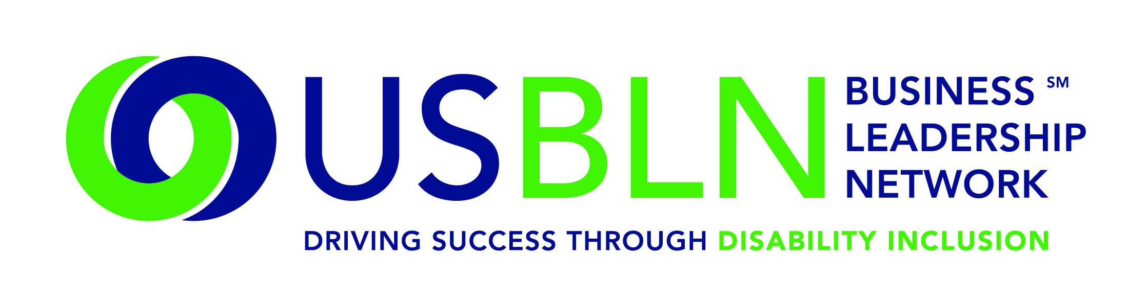

USBLN technology HUB to connect certified disability-owned businesses to corporate buyers
Tool will help promote job creation and competitive contracts

For Immediate Release Contact: Shawna Berger
Sept. 13, 2016 Phone: (800) 706-2710

WASHINGTON, D.C. (Sept. 13, 2016) – The US Business Leadership Network (USBLN) is launching its new Disability Supplier Diversity Program (DSDP) technology tool, which will provide certified disability-owned and service-disabled veteran disability-owned businesses the opportunity to promote their cost-competitive businesses to corporate buyers and decision makers.

The USBLN’s certification process is a critical tool to assist disability-owned business enterprises (DOBEs) and service-disabled veteran disability-owned business enterprises (SDV-DOBEs) access to supply chain contracting opportunities. The new USBLN Certification and Sourcing HUB will allow the organization to certify more DOBEs and SDV-DOBEs by improving the efficiency of the overall certification and administrative processes. This expanded pool of disability suppliers will bring increased innovation and competitiveness to the marketplace, promote job creation and provide people with disabilities greater self-employment and economic opportunities.

“As we enhance our outreach and provide a sourcing technology solution that our corporate partners expect, we believe a major outcome will be an increase in business for our certified disability-owned businesses,” said Jill Houghton, President and CEO, USBLN. “We are thankful for our founding partners Mitsubishi Electric America Foundation, Northrop Grumman Corporation, Wells Fargo and our technology partner, AudioEye, for their commitment to expanding economic opportunities for disability suppliers.”

“At Northrop Grumman Corporation, we strive to provide equal access and opportunity to all suppliers,” said Gloria Pualani, Corporate Director, Global Supplier Diversity Programs and Government Relations, Northrop Grumman Corporation. “We believe diversity in our supply base is integral to our continued success. It strengthens our solutions and builds value for our customers. The new Certification and Sourcing HUB will allow us to seamlessly access the capabilities of certified disability-owned business enterprises and service-disabled veteran disability-owned enterprises and take advantage of their products and services. Northrop Grumman is proud to be a USBLN founding tech partner and assist in the creation of this new innovative and forward-thinking business solution promoting certification and disability supplier inclusion.”

“Wells Fargo values and promotes diversity and inclusion in every aspect of our business and at every level of the organization,” said Regina Heyward, Senior Vice President and Head of Supplier Diversity, Wells Fargo. “USBLN’s technology expansion will enable us to more effectively locate qualified and value-added suppliers with disabilities who are competitive, innovative, and focused on providing solutions. We are proud to partner with the US Business Leadership Network to drive performance by leveraging disability inclusion in our supply chain.”

“At Mitsubishi Electric America Foundation, we are dedicated to promoting the full inclusion of people with disabilities in society by empowering them to lead productive lives,” said Kevin Webb, Senior Director, Mitsubishi Electric America Foundation. “We are proud to support the US Business Leadership Network in its efforts to develop certified disability supplier inclusion solutions to help empower disability-owned business enterprises. The new Certification and Sourcing HUB will greatly enhance these efforts.”

“As a company whose core mission is technology and innovation, AudioEye is devoted to reducing the digital divide and creating readily accessible tools that provide an optimal user experience for the community of individuals with disabilities we seek to serve,” said Todd Bankofier, Chief Executive Officer, AudioEye, Inc. “Equipped with the AudioEye solution, the new USBLN Certification and sourcing HUB will allow users with disabilities to consume content, independently, and interact with potential business customers and other certified suppliers. Not only have we ensured full access and usability for users accessing the USBLN application using their own assistive technologies, but we have also provided free web enhancement tools that help improve the user experience for everyone. In an on-going capacity, we look forward to serving as the accessibility advisor and maintaining the performance and utility of the new system.”

The outcomes for both corporate buyers and disability-owned businesses are strong with the implementation of the HUB. For more information on the Certification and Sourcing HUB or to learn more about becoming a certified disability-owned business, visit our website.

About the US Business Leadership Network (USBLN)
The US Business Leadership Network (USBLN) is a national non-profit that helps business drive performance by leveraging disability inclusion in the workplace, supply chain, and marketplace. The USBLN serves as the collective voice of nearly 50 Business Leadership Network affiliates across the United States, representing more than 5,000 businesses. Additionally, the USBLN Disability Supplier Diversity Program® (DSDP) is the nation’s leading third party certification program for disability-owned businesses, including businesses owned by service-disabled veterans.

###

