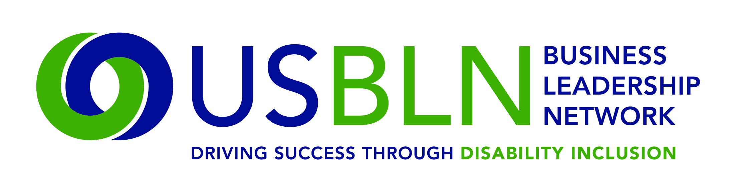

2017 USBLN® ANNUAL LEADERSHIP AWARDS
Advocate of the Year-Supply Chain Inclusion
Award Nomination Form

The "Advocate of the Year-Supply Chain Inclusion” Award recognizes the individual advocate and/or procurement champion, who have provided exceptional support in the development of USBLN®, certified Disability-Owned Business Enterprises- DOBE®s, Veteran-Disability Owned Business Enterprises (V-DOBEs™) and Service-Disabled Veteran Disability-Owned Business Enterprises (SDV-DOBEs™) and goals of the USBLN® Disability Supplier Diversity Program® (DSDP). The “Advocate of the Year-Supply Chain Inclusion” is someone who has demonstrated outstanding commitment to the utilization and growth of disability-owned businesses.

Award criteria:
- The nominee must be an individual from the corporate or government sector.
- Nominee’s organization must be a current active member of the USBLN® and Disability Supplier Diversity Program® (DSDP).
- The nominee must have achieved spend or increased spend with DOBE®s/SDV-DOBEs™, influenced supply chain and strategic sourcing processes or promoted disability business utilization within their organizations or in external outreach.
- The nominee must be active in advocating for and advancing disability business inclusion, continuously and current for the past calendar year.
- The nomination must be submitted with at least two (2) letters of support with one (1) letter of support from a certified disability-owned business enterprise (DOBE®), Veteran-Disability Owned Business Enterprises (V-DOBEs™) or Service Disabled Veteran- Disability Owned Business Enterprise (SDV-DOBE™).
- Nominees may be supply chain category managers and buyers, corporate business leaders, business leaders, supplier diversity managers/directors/team members, or BLN leaders.
- Self-nominations are accepted.
- Finalist must be prepared to accept the award that will be presented on Wednesday, August 23rd during the 2017 USBLN® Conference.
- Time period covering actions and activities described in this form shall be from January 1, 2016 through December 31, 2016.
Please complete the nomination form in its entirety: (Limit responses to three pages)
Information on Nominee:

Nominee Name
Title
Organization
Mailing Address
Phone
Email

Contact information of person responsible for completing the nomination form if other than nominee:

Name
Title
Organization
Mailing Address
Phone
Email

Contact information of primary company representative to be notified if nominee is a finalist:

Name
Title
Organization
Mailing Address
Phone
Email
Website

Contact information of a secondary company representative to contact if nominee is a finalist:

Name
Title
Organization
Mailing Address
Phone
Cell Phone
Email
Please provide a brief bio (no more than one page) for the committee to review. Supporting documents are encouraged and will not count against word limits.

- What was your total spend with DOBE®, V-DOBE™ and SDV-DOBE™? Please provide one or more examples of how you personally assisted the inclusion of a DOBE®, V-DOBE™ and/or SDV-DOBE™, using one of the following methods: mentoring, bid opportunities or contract awards. (1,000 words or less) 25 points

- Please describe the personal time you committed to DSDP and USBLN® activities (i.e. securing financial support internally, presentations, conference workshops, planning and development of DSDP strategies and programs, outreach events). Be specific about your role. (1,000 words or less) 25 points

- Do you have processes in place that allow DOBE®, V-DOBE™ and/or SDV-DOBEs™ to be identified within the Supply Chain? Describe strategies you use or outreach efforts to ensure bid opportunities include USBLN® certified DOBE®s V-DOBEs™ and /or SDV-DOBEs™. (1,000 words or less) 25 points

- Please provide any other supporting information to help the awards committee in the decision making process including promoting public awareness of DOBE®s, V-DOBEs™ and/or SDV-DOBEs™ and the Disability Supplier Diversity Program® (DSDP) and serving on a DSDP committee or project team. (500 words or less) 15 points

- Why is the nominee deserving of the “Advocate of the Year-Supply Chain Inclusion” Award?
(500 words or less) 10 points

Total Points Possible = 100

PLEASE DO NOT CONVERT FORM TO PDF. Submit your electronic nomination to: Adele@usbln.org. General questions about this submission should be directed to Cami Turcotte at cami@usbln.org.

The deadline for nominee submissions is 5 p.m. EST on Friday, April 7, 2017. Award recipients will be selected by committee and will be announced at the USBLN® 2017 20th Annual Conference & Expo in Orlando, Fla. on August 23, 2017. Please note that late nominations will not be accepted.

Thank you for submitting your nomination to the
2017 USBLN® Annual Leadership Awards!

