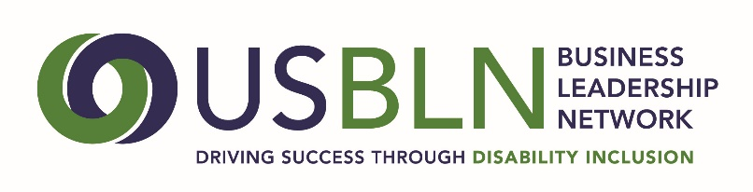
2017 USBLN® ANNUAL LEADERSHIP AWARDS
Employer of the Year Nomination

There are two categories for Employer of the Year award – one for companies with 100,000 or more employees and one for companies with less than 100,000 employees. Companies are recognized for exemplary policies, strategies and initiatives that have resulted in measurable results in the areas of disability inclusiveness in the workplace, marketplace and supply chain.
For this category, a company must self-nominate. A company must also be a member of the USBLN® to be considered for this award.
The nomination must be submitted by or on behalf of the company’s headquarters and be based on the achievements, policies and practices of the company and not on one branch or unit.
Note: Employer means all employers except non-profit service providers and government agencies. Since the USBLN recognizes that building a disability-inclusive company is a cumulative effort done over time, the information presented should reflect this and include recognitions and awards received in previous years.
*If you have received this award within the past 3 years you are not eligible to apply.
Please complete the nomination form in its entirety:
- Company Name:
2. Contact information of primary company representative to be notified:
Name
Title
Organization
Mailing Address
Phone
Email
Website
3. Contact information of a secondary company representative to contact:
Name
Title
Organization
Mailing Address
Phone
Cell Phone
Email
4. Contact information of person responsible for completing the nomination form:
Name
Title
Organization
Mailing Address
Phone
Email
5. Please provide an overview of the company including founding date, type of industry, mission statement, head quarter’s city and state, whether it is regional, national or multi-national, number of employees in the U.S. and number of employers outside the U.S. (500 words or less)
6. Please describe what the company has done to publicize its commitment to full inclusion of people with disabilities both internally and externally, (e.g., CEO statement on the intranet and/or internet, CDO chairs meetings with sector managers on inclusion initiatives, etc. Please provide a specific example(s) of these initiatives and their results. Links to supporting information are encouraged. (1,000 words or less) 35 points
7. Please describe what efforts the company has taken to advance inclusion of people with disabilities across the enterprise in at least 8 of the following areas: recruiting, on-boarding, retention, training, advancement, marketing/public relations, customer service, community relations, facility access, inclusive facility design, information and communication technology accessibility, supplier diversity, safety, and employee benefits. Please provide specific examples including metrics if available. Links to supporting information are encouraged. (2000 words or less) 50 points
8. Please provide any other supporting information to help the awards committee in the decision-making process. Links to supporting information are encouraged. (1,000 words or less) 15 points

Please do not include any attachments. You may include links in your narrative to supporting information.
PLEASE DO NOT CONVERT FORM TO PDF. Submit your electronic nomination to: Adele@usbln.org General questions about this submission should be directed to Maggie Roffee at maggieroffee@gmail.com.
The deadline for nominee submissions is Friday, April 7, 2017. Award recipients will be selected by committee and will be announced at the 2017 USBLN 20th Annual Conference & Expo in Orlando, Fla. on August 23. Please note that late nominations will not be accepted.
Thank you for submitting your nomination to the
2017 USBLN® Annual Leadership Awards!

