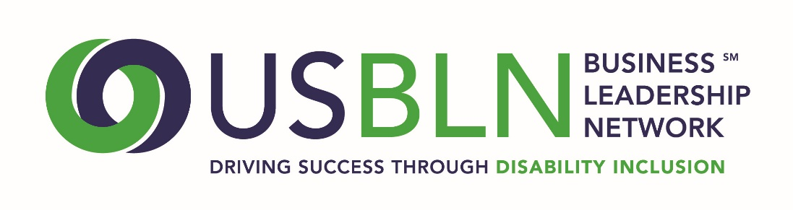

2017 USBLN® ANNUAL LEADERSHIP AWARDS
John D. Kemp Leadership Award Nomination
The John D. Kemp Leadership Award is presented to an individual who has developed or influenced the development of significant company disability employment programs and/or services that resulted in measurable, tangible and positive outcomes that dramatically improved disability employment opportunities.
Award Criteria:
- The nominee must be an individual from the business or from the non-profit or government sectors, whose activities exemplify dynamic national leadership in the area of corporate disability inclusive employment policies, programs, practices and/or services.
- The nominee must have developed or influenced the development of significant business disability inclusive employment programs and/or services that resulted in measurable, tangible and positive outcomes that dramatically improved disability inclusive employment opportunities.
- The nominee must have been actively advocating for and advancing inclusive disability employment change for a minimum of five years.
- The nomination must be submitted with at least two (2) letters of support.
- Self-nominations are not encouraged.
Please Complete the Nomination Form in Its Entirety:
1. Organization Name:

2. Contact information of primary organization representative to be notified:
- Name:
- Title:
- Organization:
- Mailing Address:
- Phone:
- Email:
- Website:
3. Contact information of a secondary organization representative to contact:
- Name:
- Title:
- Organization:
- Mailing Address:
- Phone:
- Email:
4. Contact information of person responsible for completing the nomination form:
- Name:
- Title:
- Organization:
- Mailing Address:
- Phone:
- Email:
5. Contact information for the person whom you are nominating:
- Name:
- Title:
- Organization:
- Mailing Address:
- Phone:
- Email:

6. Please describe the nominee’s major activities that exemplify his/her dynamic leadership in this area and the length of time he/she has been actively engaged in these activities.
(1,000 words or less) 30 Points
7. Please describe the significant corporate practices developed or influenced by the nominee.
(1,000 words or less) 30 Points
8. Please present the positive outcomes that resulted from the nominee’s activities and include how they were measured and any available supporting statistics.
(1,000 words or less) 30 Points
9. Please provide any other supporting information to help the awards committee in the decision making process.
(1,000 words or less) 10 Points

10. The nomination must be submitted with at least two (2) letters of support. Please remit as file attachments via email when submitting this nomination form.

PLEASE DO NOT CONVERT FORM TO PDF - submit your electronic nomination to: adele@usbln.org
General questions about this submission should be directed to Maggie Roffee at maggieroffee@gmail.com.

Award recipients will be selected by committee and will be announced at the 2017 USBLN 20th Annual Conference & Expo in Orlando, Fla. on August 23. Please note that late nominations will not be accepted.

THE DEADLINE FOR NOMINATIONS IS FRIDAY, APRIL 7, 2017

Thank you for submitting your nomination to the
2017 USBLN® Annual Leadership Awards!

