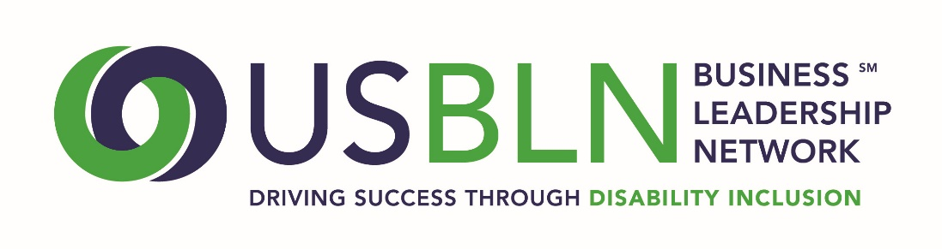
2017 USBLN® ANNUAL LEADERSHIP AWARDS
Marketplace Innovator of the Year Nomination

The USBLN® 2017 Annual Leadership Awards "Marketplace Innovator of the Year” has two categories - one for a marketing campaign or an advertisement that includes disability and one for developing products that are designed to be used for people of all abilities. A company must be a member of the USBLN® to be considered for this award.
Please complete the nomination form in its entirety:
1. Organization Name:
2. Contact information of primary company representative to be notified:
Name
Title
Organization
Mailing Address
Phone
Email
Website
3. Contact information of a secondary company representative to contact:
Name
Title
Organization
Mailing Address
Phone
Cell Phone
Email
4. Contact information of person responsible for completing the nomination form:
Name
Title
Organization
Mailing Address
Phone
Email
5. Which category is this application for? (note: if you are applying in both categories, you need to submit two separate nomination forms) Marketing Campaign ___________ or Product Design ____________.

6. Please provide an overview of the company including founding date, type of industry, mission statement, head quarter’s city and state, whether it is national or multi-national, number of employees in the U.S. and number of employers outside the U.S. (1,000 words or less)
7. Please present a narrative that provides the background, motivation, process, innovations and results that your company experienced in the marketplace category you chose. (narrative only; please do not attach documents) (2,000 words or less) 70 points
8. Please provide links to the advertisements or products cited in your narrative. 20 points
9. Please provide any other supporting information to help the awards committee in the decision-making process. (narrative only; please do not attach documents) (1,000 words or less) 10 points

Please do not include any attachments. You may include links in your narrative to supporting information.
PLEASE DO NOT CONVERT FORM TO PDF. Submit your electronic nomination to: Adele@usbln.org. General questions about this submission should be directed to Maggie Roffee at maggieroffee@gmail.com.
The deadline for nominee submissions is Friday, April 7, 2017. Award recipients will be selected by committee and will be announced at the 2017 USBLN 20th Annual Conference & Expo in Orlando, Fla. on August 23. Please note that late nominations will not be accepted.
Thank you for submitting your nomination to the
2017 USBLN® Annual Leadership Awards!

